Configuring the Application Experience
Objective
After completing this lesson, you will be able to configure application forms based on organizational fields to tailor the application process for different job types.
Tailored Application Experiences Configuration
In SmartRecruiters, you can configure application experiences (or forms) to provide tailored and optimized application processes for different types of jobs within your organization. This is particularly useful if you're a global company with varying recruitment needs across different departments or locations.
The holistic candidate experience involves the following question types:
- Standard or custom application forms (Determined by org fields to tailor the application experience by organizational requirements).
- Application screening and job screening questions (Can be configured as branching questions and/or knockout questions).
Hint
Best Practice - Carefully consider the length of application forms/screening question sets to find a balance between collecting all the information the recruiters need to make their decisions and not requiring so much information that the application rate reduces too much due to candidate drop off.
Default Apply Experience
On the Application Management tab, you'll find your default application experience, which applies to all jobs that don't meet the criteria defined for other application experiences. You can edit this default application by clicking the Edit icon.
Note
While you can't change the title of the default application, you can configure the information collected from applicants.
Custom Application Experience
To create a new application experience, click the New Application Experience button. For example, you might want to create an application specifically for Retail Store positions.
When creating a new application, you can customize the following:
- Application Title: Give your application a descriptive title (for example, Retail Store Application).
- Required Fields: Toggle fields on or off to determine what information applicants must provide. For example, you might remove the resume requirement for retail positions.
- Field Settings: Some fields, like Education and Place of Residence have Settings icons that allow for further configuration.
  - For example, for Education, you can choose to collect the dates a candidate attended school or university. Or for fields like Place of Residence, you can choose to collect the city, region, or require a postal code.
- Organizational Field Assignment: This is where you define which jobs will use the new application experience. You can assign the application based on organizational fields like Department, Country, or Brand. For example, you could assign the Retail Store Application to all jobs with the Department field set to Retail.
Another example is that if it is a legal requirement to collect a candidate’s nationality when they apply for a job in a particular country, a screening question set can be applied only to jobs in that specific country.
Activation: Once you've configured the application, you can use the Activation toggle to set the date that the application should go live. The system will check for conflicts with other application experiences and display an error if any are found.
Tracking Reapplied Candidates and the General Application
The Configuration tab within the Application Experience page offers additional options:
- Track Reapplied Candidates: Enabling this will identify candidates who have previously applied for the same job within a specified timeframe by applying a Reapplied badge to their application. This helps identify serial applicants.
- General Application (Get in touch): You can view and copy the HTML code for your General Application, which allows candidates to submit their information without applying to a specific job. It is important to note that only users with admin or extended roles can review general applications.
Required and Configurable Fields for the Application Experience
Administrators can manage which fields are required when candidates apply for a job. These include:
Required Fields (Always Mandatory)
- First Name/Last Name
- Email
Configurable Fields (Can Be Set as Required, Optional or Hidden)
- Easy apply: Can be configured one by one for various platforms. If Easy Apply is enabled, resume upload is always possible in this section and cannot be deactivated.
- Place of residence: If enabled, candidates can select a city or region from a dropdown list or enter a postal code. To choose which, click the Settings icon.
- Phone Number: If enabled, candidates must enter a phone number.
- Experience: If enabled as Required, candidates must add at least one entry for experience.
- Education: (Can be configured for schools and dates separately) - If enabled as Required, candidates must add at least one entry for education.
- Resume: If enabled, candidates must upload a resume attachment.
- Social Media: Can be selected one by one for various social media platforms.
- Message to the Hiring Manager: If enabled as Required, candidates must add at least one symbol.
Configure the Default Application Experience
Configure the default application form by adjusting the visibility and requirement settings of individual fields.
Note
This has no impact on the hosted application processes using the API.
Steps
- Navigate to Settings.
- In the Career Page Setup section, select Application experience.
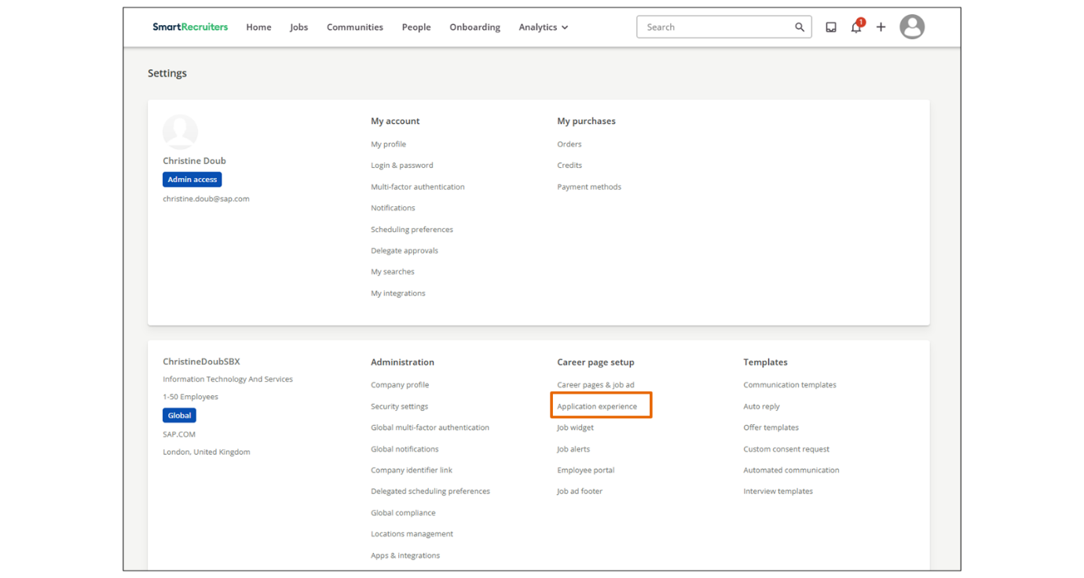
- In the Application Management tab, click the edit icon in the row of the specific application experience that you want to configure.
- Enable or disable the fields you wish to use in the default Application Experience.
  - Use the visibility switch to activate the fields.
  - Use the required box to make the field required.
  - If available, select the Settings icon to enable additional field-specific configurations.
- Select Save.
Configure a Custom Application Experience
Creating custom application experiences allows multiple application processes which create opportunities for organizations to tailor the application process to specific departments, countries, brands, and ownerships, ensuring relevance and appropriateness for each context. It also enhances the candidate experience by making the application form more relevant and easier to complete.
Steps
- Navigate to Settings.
- In the Career Page Setup section, select Application experience.
- Select New Application Experience.
- Enable or disable the fields you wish to use in the application experience.
- Within the Org Fields section, assign relevant org fields to determine which jobs the specific application configuration will apply to.
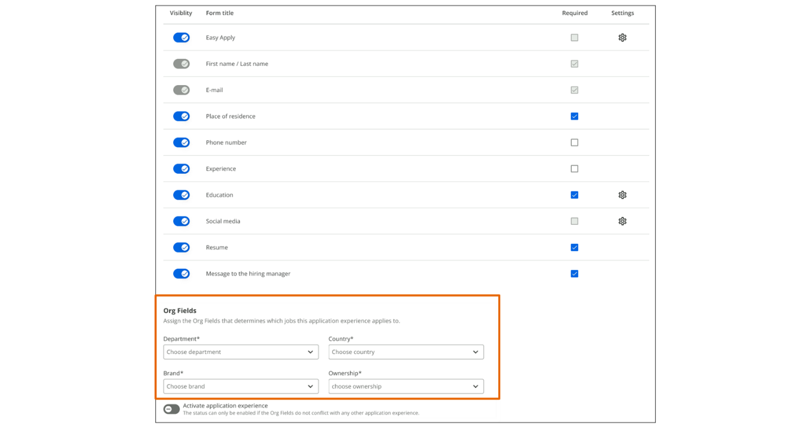
- Select the Activate Application Experience switch to activate the custom application form.
View of Application Experience During Job Creation
When creating a job, the system indicates which application experience will be applied based on the organizational fields selected. On the job creation page, a notification will display the name of the application that will be used. This ensures that the correct application is applied, providing the best possible experience for candidates.
Watch the video below to gain more knowledge about configuring the application experience.
This video is for demonstration purposes. Any references made in this video to previous or later videos in this course (including titles, numbers, links, or sequence) may differ from the current course structure. Additionally, some functionalities shown may have evolved over time due to ongoing enhancements or business decisions.
Summary
- Application experiences can be tailored using organizational fields to optimize the application process for different job types.
- Administrators can manage field requirements such as First Name/Last Name and Email and configure optional fields like Education and Place of Residence.
- Custom application experiences can be created and assigned to specific jobs based on organizational fields like Department, Country, or Brand.
- The system indicates which application experience will be applied during job creation, ensuring the correct application is used.
In this video, we're going to look
at how to configure application experiences for candidates that will
allow for tailored and optimized application processes for different
types of jobs within your organization. For example, perhaps you're a
global retail company that needs a different application process
for corporate jobs versus retail store jobs, or maybe you need to
configure different applications per location. You have the
ability to configure different applications based on org fields
on the Application Experience page, located under the Career
Page Setup section in Settings. On the Application Management
tab, you'll see your default application experience, as well
as any other applications you've created. You can edit your
default application by clicking the Edit icon, located to the
right of the application name. Since this is the default
application, you can't change the application title, but you can
configure what information should be collected, and we'll go
over these options in a moment. Also, you'll notice there are no
org fields listed at the bottom of the page as this application will
be used for all jobs that do not already meet org field criteria
for other application experiences. Going back to the application
management tab, now we're going to create a new application
experience by clicking the new application experience button
at the top right of the page. For this example, we're going to
create an application for our retail store position so we'll title this
application retail store. For retail store roles we don't need to have
applicants include a resume so we'll toggle that field off. We also
don't need to have them include a message to the hiring manager and we
don't need to ask for their social profiles so we'll toggle those
off as well. To the right of the fields you'll see the check boxes
that make the fields required. For this application we want the experience
field to be required so we're going to click the checkbox. You'll
also notice that the name and email fields are greyed out and that's
because they are both required information that the system needs to
create an application so those fields are not editable. Some fields have
a settings icon which allows you to configure additional information
related to that field. For example if we click on the Settings icon
for the education field, we're able to select if we want to also collect
education dates along with the institution information which is
required if the field is enabled. For this application experience we'll
make the education field optional. There are also additional options for
configuring the place of residence field. When you click the Settings
icon you can choose to have the applicant only provide their
city or region or you can require a postal code. When an applicant
provides a postal code it allows users to better utilize the postal code
proximity search in the system. Once we're done selecting the
application fields, we can scroll down to assign an org field. Right now,
we have the default application experience being assigned to all jobs
but we want to make sure that any retail store roles use this application
instead. To do that we're going to use the department org field
and select the retail option from the drop down. Now that the org field
is set, this application will be applied to any job that has retail
selected as the department. Other org fields you might use to assign
application experiences include country or brand but you can use any
org field to assign applications. The final step in setting up the
application is toggling on the Activate option at the bottom of
the page. The system will only allow activation if the org
fields set for this application experience do not conflict with
other applications. If there is a conflict when you click the create
button the system will display an error showing which application
experience is causing the conflict, and then you can adjust
the org fields accordingly. Once you're ready to save
your application, click the Create button at the
top right of the page. Now our retail application experience
has been saved successfully, and you can always go back in
and edit any of your applications as needed. You can also deactivate
an application by toggling off the Activate button on
the Application edit page. The second tab on the application
experience page is configuration. First on this page we have the ability
to track candidates who reapply to the same job. This can be
really useful if you do have those serial applicants as this will add
a reapplied badge on their profile which makes them easily identifiable
to the hiring team. The option to track candidates who reapply is a
yes or no option and if you do turn it on you can determine when the
reapplied badge should be applied depending on the timeframe within
which a candidate has reapplied. For example, you may only want to
track candidates who reapply within 12 months or maybe you want to track
any time a candidate reapplies. You also can view and copy
the HTML code for your general application so you can place it
on your career site or use the URL anywhere you want to place the
link. Clicking on this link will take the candidate to the general
application which allows them to submit their information
without applying to a specific job. Please do keep in mind that with
a general application, only users with an admin or extended role are
able to review this application. Now let's review how the application
experience is indicated while creating a job. We're going to
create a job for a position at one of our retail locations. And as
we go through the job creation process, on the third step where
we'll enter our job field information, under the job fields there is
a notification stating which application will be applied to this
job. Currently, the default application will be applied since no org field
selections have been made yet. But once we set the department
field to retail, the notification will update, and now the retail
store application will be applied. So users will be able to make sure
the correct application is being applied to their job, ensuring
that candidates will have the best application experience possible.
Thank you for watching this video on configuring multiple application
experiences in SmartRecruiters.

Configuring Application Fields
Objective
After completing this lesson, you will be able to configure application fields in SmartRecruiters to capture additional candidate information throughout the hiring process.
Fields for Managing Candidate Applications
In SmartRecruiters, you can create application fields that allow you to capture additional information from candidates at various stages of the hiring process. This information can be used for recruiter notes, forms, offer letters, and new hire paperwork. These application fields in SmartRecruiters enable you to capture and manage this information effectively, ensuring a streamlined, comprehensive recruitment process.
Note
Application fields are separate from screening question answers.
Administrators can create custom application fields and select from various data types to collect the information they need for integrations, approval workflows, and other processes. In addition:
- Application fields are automatically converted to merge fields, which can be added to offer letter templates.
- Each field can be added to all your candidates or only those who apply to a specific job group. You'll define groups using a set of org field values.
Where Application Fields Appear
Once you select a standard field or create a custom field, you can configure its placement, visibility, and whether it is required. Application fields can appear in several key areas within SmartRecruiters:
- Candidate Profile: The field will be added to the candidate's profile in the Application fields widget. Recruiters can use them to record information gathered during phone screenings or interviews.
- Offer Tab: Candidate fields can be integrated into offer templates, allowing you to populate offer letters with relevant information, such as salary, orientation date, and other essential details.
  - You can also choose whether an edit to this field requires reapproval through the offer approval process. For example, you might decide that any salary change needs reapproval, but a change to the start date might not.
- New Hire Form: When hiring a candidate, you can use application fields to confirm information on the new hire form, ensuring accuracy and completeness.
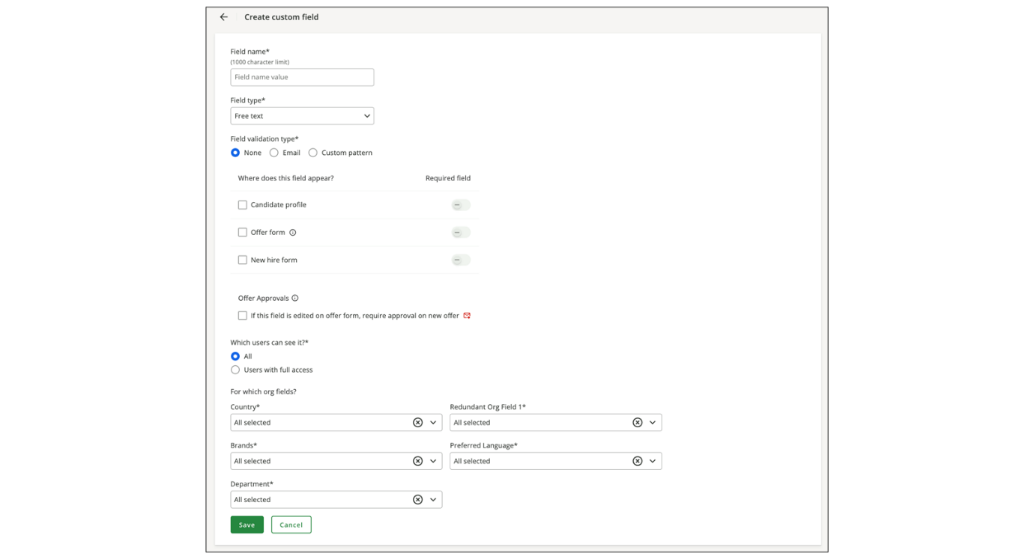
Standard and Custom Application Fields
SmartRecruiters provides a set of default fields, such as first name and last name, that are automatically captured during the application process. You can add these default fields to other areas, such as forms or the new hire stage, if you need the candidate to reconfirm the information.
By default, the system includes standard application fields, including but not limited to the following:
- First Name
- Last Name
- Applicant Email
- Applicant Birthdate
- Applicant School
You can also create custom application fields if the list of standard fields does not meet your organization’s requirements. For example, the organization may have multiple bonus amounts to capture and include in the offer.
Application Field Types
Applicants can provide information using predefined fields. The table lists application field types and descriptions.
Field Type | Description
Free Text – Basic | Users are presented with a large free-text box for this data type, with a limit of 20,000 characters.
Free Text – Email | When creating a free text field, if you select Email as the validation type, users must enter a valid email address (including the @ symbol and the domain).
Free Text – Custom pattern validation | A custom pattern field in data entry is your personalized space to define input formats customized to your data needs. Empowered with a pattern design console offering flexibility to implement specific data validation rules, it's like having a custom key that fits your unique needs, whether it's a specific format, combination, or sequence.  This feature allows admins to tailor input according to predefined patterns, ensuring accuracy and adherence to the required format.
Date | A date picker is a small digital calendar that helps users and applicants choose and enter dates easily. Instead of typing dates manually, users and applicants can click dates in the calendar that pops up. This is especially helpful when dealing with users who are familiar with both mm/dd/yyyy and dd/mm/yyyy.  Date validation limits can be set to define or constrain the boundaries of a date value, ensuring that entered values meet specific criteria within a business or system context.  - None: No criteria defined, users can input any date.  - Before date: With this validation type, the date is required to fall before a specified date, inclusive.  - After date: The date is required to fall after a specified date, inclusive.  - Between dates: The date is required to fall between two specified dates, inclusive.
Numerical | A numerical field in data entry allows users to enter only numeric values, including whole numbers or decimals, with a maximum of 2 decimal points.  Numerical validation will enable admins to tailor input within predefined numerical limits, ensuring accuracy and adherence to the required numerical boundaries.
Percentage | A percentage field is a user-friendly way to input percentages. It appears as a box where you can enter a number followed by a percentage sign (%).
Currency | A currency field is used to input monetary values. It includes a dedicated selection box for users to choose from the global currencies supported by SmartRecruiters, and a box for entering only positive numbers with a maximum of 2 decimal points.
User Picker | The user picker field is a user-friendly way to select individuals from a list in a digital form or application. It includes a dropdown that provides search functionality, enabling users to easily find and select specific users.
Yes/No | A Yes/No field is a user-friendly way to answer simple questions with a clear and concise response. It presents users with two options: Yes and No.
Single Select | A Single Select field is a user-friendly way to choose one option from a list of possibilities. It's a menu where users can search and pick the most relevant choice with just a click. Administrators can specify a list of up to 1,000 custom values, each with a maximum of 1,000 characters; users can select only one item from this field.
Region | When the user starts typing, this field will display a list of regions in any country that match the criteria. The user will be able to choose one from the list.
Country | A list of countries from which the user will be able to select one.
Create Custom Application Fields
Steps
- Navigate to Settings.
- Select Application Fields in the Configuration section.
- Select Add application field.
- Select Create Custom field.
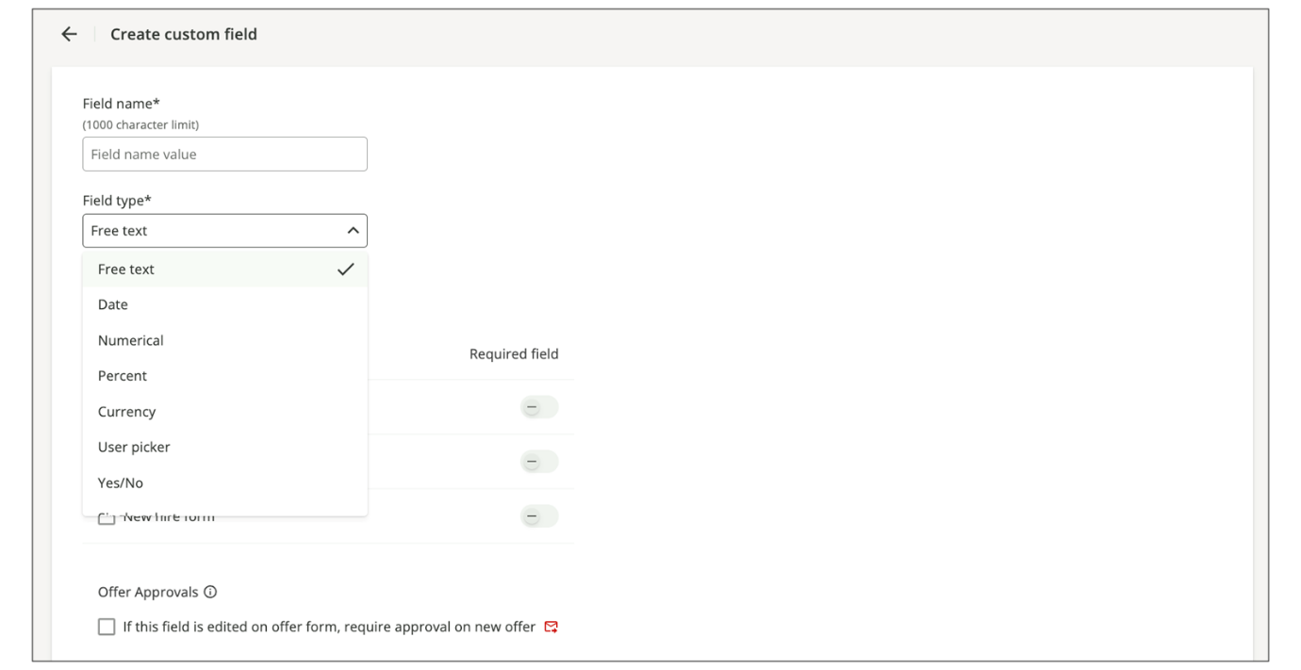
- Enter a name in the Field name field.
  - Enter a descriptive name for the field.
- Select where the field should appear.
  - Choose between Candidate Profile, Offer Form/Approval Form, New Hire Form. You can select multiple options.
  - If creating an Offer Form field, select whether Re-trigger the Offer Approval workflow is required if this field changes (e.g., bonus percentage changing on an offer may require re-approval).
- Define who has access to view the field (all users or users with full access).
  - Select all to allow anyone with access to the job to see the field and its values.
  - Select users with full access to restrict visibility to users with full access to the job, such as a Hiring Manager, Recruiter, or Executive on the job's hiring team.
- Define if this field should become dependent on org fields.
  - Selecting org fields limits field visibility to specific countries or departments.
- Click Save.
Note
Custom application field labels cannot start with a numeric character. They must begin with a letter A-Z; otherwise, this will negatively affect the functioning of merge fields.
By effectively utilizing candidate fields, you can streamline your recruitment process, capture essential information, and ensure a consistent and comprehensive candidate experience.
Custom Patterns for Free Text Fields
This feature allows admins to tailor input according to predefined patterns to a free text field type, ensuring accuracy and a candidate’s adherence to the required format.
Empowered with a pattern design console offering flexibility to implement specific data validation rules, it's like having a custom key that fits your unique needs, whether it's a specific format, combination, or sequence.
Each custom pattern consists of Segments, and each segment has multiple validation rules that define its length and content, like assembling building blocks to create a specific textual structure. The arrangement and composition of these segments follow predefined rules, resulting in a structured, meaningful format.
For example, if creating a free text field with a custom pattern to ensure that a candidate inserts a phone number following a specific pattern, segments would be configured as follows:
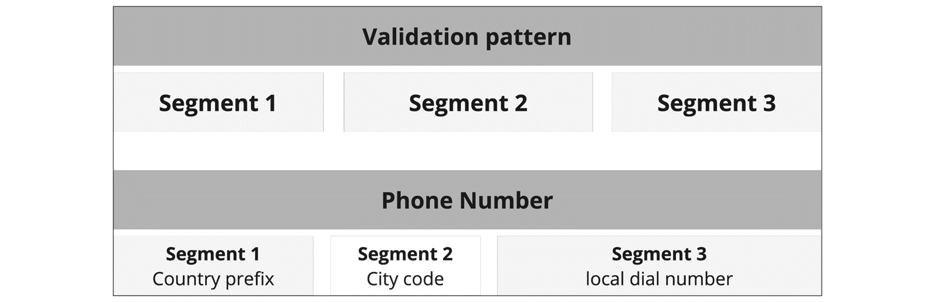
Segment Length Type
When creating custom patterns for a custom field, you will need to define the length for each segment configured. Segment length type refers to how the length of a segment is defined or constrained, ensuring that entered values meet specific length criteria within a business or system context.
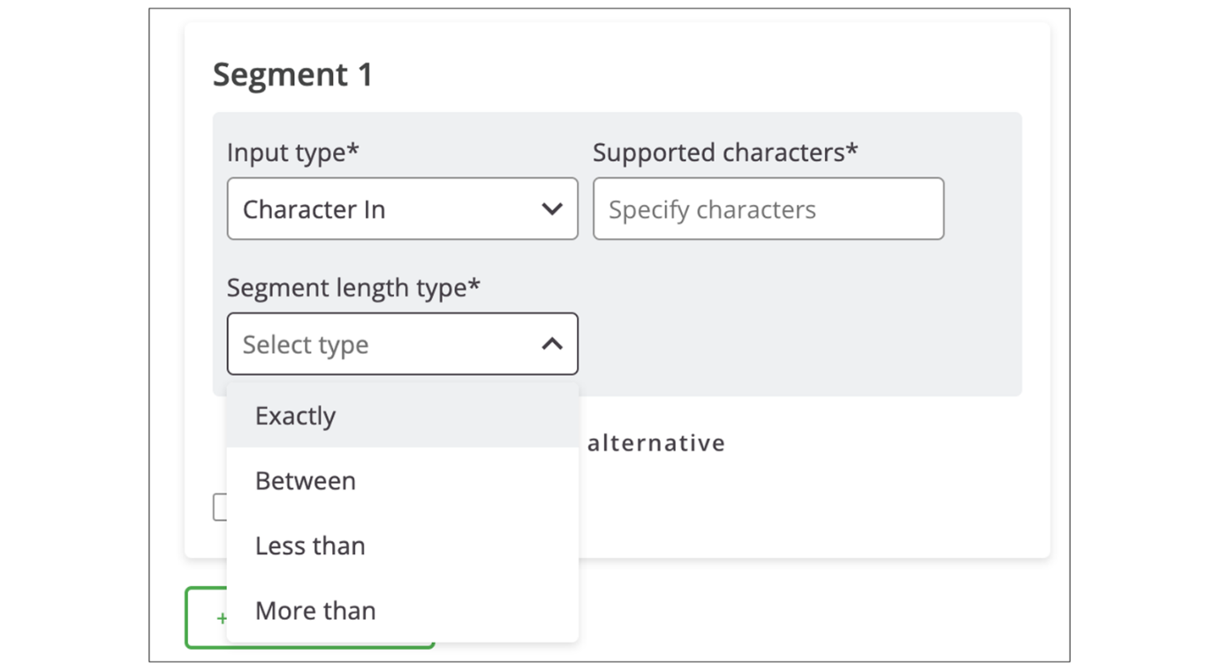
- Exactly: In this segment length type, the length of the segment must precisely match a specified value.
  - Example: If a system requires a four-digit PIN, the segment length type would be Exactly 4.
- Between: With this segment length type, the length of the segment is required to fall within a specified range, inclusive.
  - Example: If a postal code must be between 5 and 9 characters long, the segment length type would be Between 5 and 9.
- Less than: This segment length type indicates that the length of the segment must be shorter than a specified value.
  - Example: If a username is required to be less than 20 characters, the segment length type would be Less than 20.
- More than: In this case, the length of the segment must exceed a specified value.
  - Example: If a job reference code must be more than 10 characters long, the segment length type would be More than 10.
Segment Options
Segment options define how different segments relate to each other within a pattern. These segment options help define the flexibility of data formats or input requirements. They ensure that variations or optional components can be accommodated within a specified data pattern.
The following segment options are available to configure:
- Add alternative: It is possible to define alternative segments, which means that multiple segments are provided as alternatives or options. Any of these alternate segments is required or should be present.
  - Example: If a phone number can be either in Germany or Poland, the data format allows either a first segment of +48 or +49.
- Mark segment as optional: Selecting this option means that a particular segment is not mandatory and may be omitted without affecting the overall pattern validity.
  - Example: If a specific ID prefix can be provided or not, the segment must be marked as optional.
Video
Watch the video below for more details about creating candidate fields.
This video is for demonstration purposes. Any references made in this video to previous or later videos in this course (including titles, numbers, links, or sequence) may differ from the current course structure. Additionally, some functionalities shown may have evolved over time due to ongoing enhancements or business decisions.
Summary
- Application fields in SmartRecruiters allow you to capture additional information from candidates at various stages of the hiring process.
- Administrators can create custom application fields and select from various data types to collect the information they need.
- Application fields can appear in the candidate profile, offer tab, and new hire form.
- SmartRecruiters provides a set of default fields, and you can create custom application fields if the standard fields do not meet your organization’s requirements.
- Custom patterns for free text fields allow administrators to tailor input according to predefined patterns, ensuring accuracy and adherence to the required format.
Hi, in this video we're
going to take a look at candidate fields in SmartRecruiters. So if there's additional information
that you need to capture from a candidate after they've applied,
so whether it's just information a recruiter may need to
capture as they're talking to a candidate during a phone screen, or
perhaps it's additional information you need to send out to the
candidate later on in the process, or information needed for offers
or new hires that you want to be able to report on or use
for any integrations we can use candidate fields to do that.
Before we dive in to settings and admin to take a look at
how we configure those I just want to show you first where
that information can appear. So the first area where we can
see candidate fields are in this section on the candidate profile
called application fields. They're called application fields
because the information that is entered here relates specifically
to this application for this candidate. So the candidate may
have multiple applications in which the information recorded here
could be different per application. So the type of information you may
want to add here is anything that maybe the recruiter is going to get
from the candidate or the hiring manager as they're talking to them
through phone screens or interviews and then I can simply come in, edit
and update the fields as needed. The next area where we can see those
candidate fields is on the forms tab so if we send a form out to a
candidate to provide us with additional information later on during the
application process when they complete that form any fields that are
part of that form will be available for us here so here we'll be able
to see what information has been completed by the candidate. Of course
when we get to offer stage there are definitely going to be some
fields that we need to capture but we'll see later on when we look at
the offer process, how we pull these fields into offer templates to
have them appear on this tab. I can see here, for example, that I've
got information like the salary, their orientation date, along with
their name details. So the Offer tab is where we can also have information
appear. And then finally, when we go to hire a candidate, we can
have fields appear here also. So anything I want to confirm at the
point of hiring can populate it on the new hire form here. So if I navigate
to settings in admin, I will find my candidate fields underneath
configuration. And here, once I enter this area, I'll see a list of any
fields that I've already created. So the fields that we have
available here, there are a bank of default fields that you can pull
through. So things like first name, last name, for example, we obviously
have those fields in the system already, and we're capturing that
information when the candidate actually applies. But if we want
to have those fields populate anywhere else, so maybe we need to
have the candidate reconfirm via a form, or we want to confirm them
again and offer a new higher stage, then we can add those fields to
our list of fields available to use. To add a field, you can see
the button in the top right hand corner here. I can choose from
those pre-existing fields, so first name, last name, for example, I can
find in this list. And I'll also find additional data of points
that I can pull through here. A lot of these appear here because
of integrations we have built with different partners but of course
you can utilize them if you wish. When you use an existing field, so
let's say I want to pull through a phone number for example, I
don't have any options as to the type of field it is because this
field already exists. So in my preview over here on the right hand
side I can see this is actually a text field to enter the
information into and I can't change that to let's say a drop down type
field or some other type of field. If I want to create something
custom then I have the option to come through to the bottom here
and create custom field. When I create a custom field you'll see
the available field types on the left hand side so whether it's a
free text field, date type field, some kind of number so percentage
or currency or numerical and I have the user picker field if I want to
allow the user to look up a user in the system and I have a yes no
and single select field so that's my drop down field here. I'm just going
to create a free text field I'm just going to call it training
example today as I type you'll see in my preview at the bottom that
appears here for me and then I have a number of options so the first is
where do I want this field to appear so candidate profile this means it
will appear on that little panel of application fields it also means
it will appear on that form tab if we then later on add this field
into a custom form which we'll look at in a later video. I can choose
whether or not I want to make the field required by toggling the
button on and off here. I can choose whether it's part of the offer approval
process so when we look at offers you will see that we can add fields
here and not have them specifically stated here as being part of the
offer approval by adding them as a merge field into our offer templates
they'll automatically be available for us but if it's a field that's
particularly important for an offer approval process then I can
choose that it should appear on all of the offer approvals and then
finally the new hire form so that was that other tab when we confirm a
hire in the system I can have that field appear here for confirmation
and as you can see I can choose that they're required on some areas
and not others. Of course, as I mentioned, if this is just something
that perhaps you want to pull through into an offer template, you don't
need to check any of these boxes. We just need to make the field
available for us to use in the future. If we have stated that this should
be part of offer approvals, we have an additional option that we can
say if this field gets edited on an offer, it will re-trigger the
approval process. This is particularly useful if we're going to say,
well, this is important for offer approvals. Generally, we want to make
sure that it triggers a reapproval if it gets amended later on and
then your final options at the bottom are who has access to be able
to see this field so all users in the system who have permission to
see these different areas in the system or should it just be our
users with full access and then for which org field so if this particular
field is only relevant for a specific country or a specific
department then I can make sure that it only appears in that particular
instance so if I say this field is only applicable perhaps for the Bahamas
I can check this box here and know that it will only appear in
these areas for jobs in the Bahamas. Once I have configured everything
here I can go ahead and save and that field will be added to my
list so I can see it's down here at the bottom. At any point you can
come in and edit this field but notice you cannot change the name
so just be mindful that when you create a field you want to make
sure you have the name correct and your spellings are correct. Because
whilst we can remove these fields from the system, they are not
truly deleted in that that field and its name will be retained for
reporting purposes. So it's not something we can then go and create
additionally in the future. So just be careful when you're naming
your candidate fields. So in other videos, we'll take a look at where
some of these fields will come into play, such as the custom
forms and offers. But for this one, this is how we can create our list
of candidate fields. Thank you.

Using Standard Application Screening Questions
Objective
After completing this lesson, you will be able to use Standard Application Screening Questions.
Introduction to Screening Questions
Effectively screening candidates is crucial for identifying the right talent and ensuring a smooth hiring process. SmartRecruiters offers powerful tools to create and manage screening questions, allowing recruiters to filter applicants based on specific criteria. This saves recruiters time and assists them in gathering demographic data for compliance and reporting.
Screening questions helps recruiters quickly identify the right people by gathering key information in the beginning. They can add application screening questions to job applications to filter candidates based on specific skills or experience. Similarly, community screening questions in SmartCRM help them to qualify leads by capturing relevant details before they enter the talent pool and then filter candidates based on those details.
The following question types can be created:
- Question Set: A question set is a group of predetermined questions used on the application to standardize and streamline the screening and interviewing process for a specific job or role. They are assigned to jobs via org fields.
- Community Question Set: Community questions are used in CRM lead capture forms to capture additional information about potential candidates that can be used to filter communities of talent.
- Job-Specific Questions: These questions are job-specific and can only be added by the Hiring Team of a specific job when publishing it via the Screening Questions option in the Job Ad tab. .
By tailoring your questions to the role or community, the recruiter can save time, focus on the most promising candidates, and make better hiring decisions from the start of the process.
Watch the video below for more details about Screening Questions.
This video is for demonstration purposes. Any references made in this video to previous or later videos in this course (including titles, numbers, links, or sequence) may differ from the current course structure. Additionally, some functionalities shown may have evolved over time due to ongoing enhancements or business decisions.
Pre-configured Application Screening Questions
SmartRecruiters has curated a pre-configured library of questions which contains default questions, diversity questions, and has the option to create new custom questions.
The following standard default and diversity questions can be accessed immediately using the Question Library.
Pre-configured Application Screening Questions
Category | Topic | Question
Standard | Work Permit | Are you authorized to work in <job location>? Yes/No.
Standard | Criminal Record | Have you ever been convicted, pleaded guilty or no contest to a crime, or are criminal charges pending against you? Yes/No.
Standard | Driving Current | Do you have a current driver’s license?
Standard | Driving Revoked | Has your driver’s license ever been revoked? Yes/No
Standard | Employment Record | Have you ever been terminated from or asked to leave any previous positions?
Standard | Refugee Status | Do you identify as a refugee?
Standard | Ethnicity | Are you Hispanic or Latino?
Standard | Languages | Add languages and indicate your proficiency level
Standard | Work Shifts | preferred days and hour range
Standard | Attachments | Add additional attachments
Standard | Your Name
Standard | Today’s Date
Diversity | OFCCP - Disability | Do you have (or have a history/record of having) a disability? Yes/No/Prefer not to answer.
Diversity | OFCCP - Veteran | Are you a protected veteran?
Diversity | OFCCP – Reasonable Accommodation
Diversity | OFCCP – Race and Gender | Dropdown lists for choosing both.
Diversity | Ethnicity | Are you Hispanic or Latino?
Diversity | Veteran Status | Are you a veteran? Yes/No.
Diversity | Disability Status | Do you claim disability status? Yes/No.
Note
Pre-configured questions are translated with the appropriate language being determined by the user’s browser settings, irrespective of the language used by your own custom questions.
Therefore, it is best practice to use the pre-configured questions where possible rather than creating custom questions.
Question Sets
Question sets allow you to group related screening questions and apply them to specific jobs. To create a new set, click the New set button. You can title the set, specify whether it's for internal or public use, and configure options, such as allowing candidates to submit pictures.
The configuration options enable you to assign question sets to jobs based on organizational fields like Country, Brand, and Department. For example, you can create a question set that applies to all jobs in the Customer Service and Engineering departments.
When building a question set, you can select from default questions and custom screening questions you've created. You can also change the order of questions and mark them as required or as knockout questions.
Use Standard Application Screening Questions in the Default Question Set
All SmartRecruiters systems will have a default public question set. You can customize the default question set for external and internal hiring.
Steps
- Navigate to Settings.
- Select Screening Questions within the Configuration section.
- Select the Question Sets tab.
- Select the pencil icon next to the Default set.
  - Selecting the Default set for the Public Job ad type category will create a default question set for external candidates.
  - Selecting the Default set for the Internal Job ad type category will create a default question set for internal candidates applying through the employee portal.
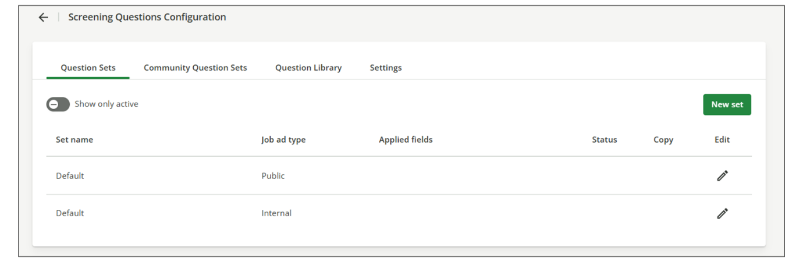
- Enable the Active setting to ensure this question set status is set to active.
- Expand the Questions section to add questions to the set.
  - If adding a pre-existing question, search for the question to add it to the set.
  - Alternatively, you can create a custom question to be added to the set.
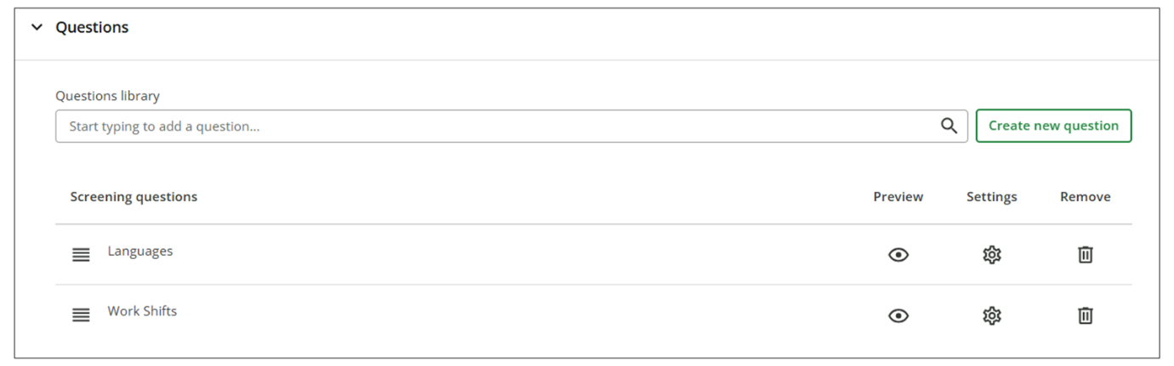
- When adding questions, you can modify the Settings (which determine the behavior of the system dependent on the answer provided by the candidate) and/or modify the Attributes. (Mark a field as required or set what user access is needed to view answers. For example, all users can view the answer).
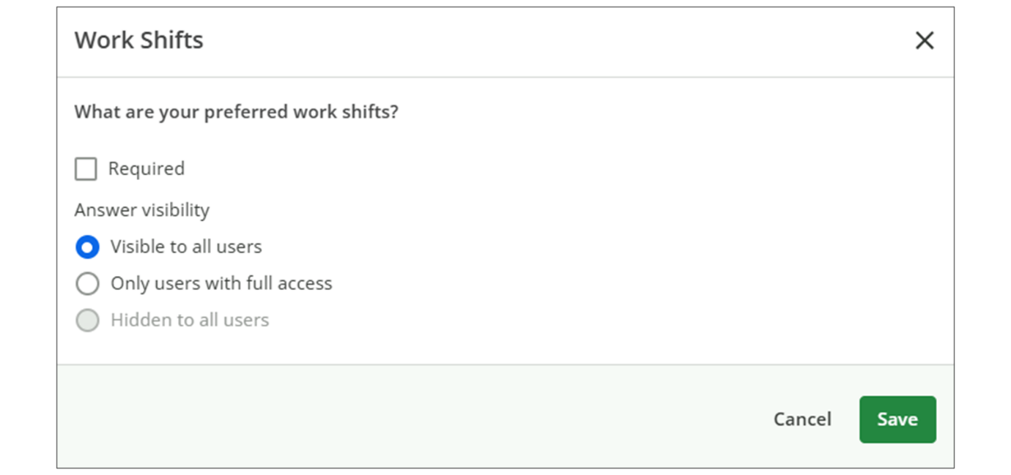
- Select Save.
Summary
- Screening questions in SmartRecruiters helps filter candidates based on specific criteria and gather relevant information.
- SmartRecruiters offers pre-configured standard and diversity questions that can be used immediately.
- Question sets allow you to group related screening questions and apply them to specific jobs based on organizational fields.
- You can customize the default question set for external and internal hiring by adding pre-existing or custom questions.
Creating Custom Application Screening Questions
Objective
After completing this lesson, you will be able to create custom screening questions and question sets in SmartRecruiters.
Candidate Screening with Custom Questions
Custom screening questions allow administrators to create targeted inquiries tailored to specific roles or departments. These questions enable you to gather essential information about candidates, ensuring they possess the necessary skills, knowledge, or experience.
By strategically implementing custom questions, you can significantly streamline the screening process and save time and resources while improving the quality of your talent pool.
Create Custom Application Screening Questions
Administrators can create up to 5000 custom questions for use across question sets, job-specific questions, and community question sets.
Steps
- Navigate to Settings.
- In the Configuration section, select Screening Questions.
- In the Question Library tab, select Create Question.
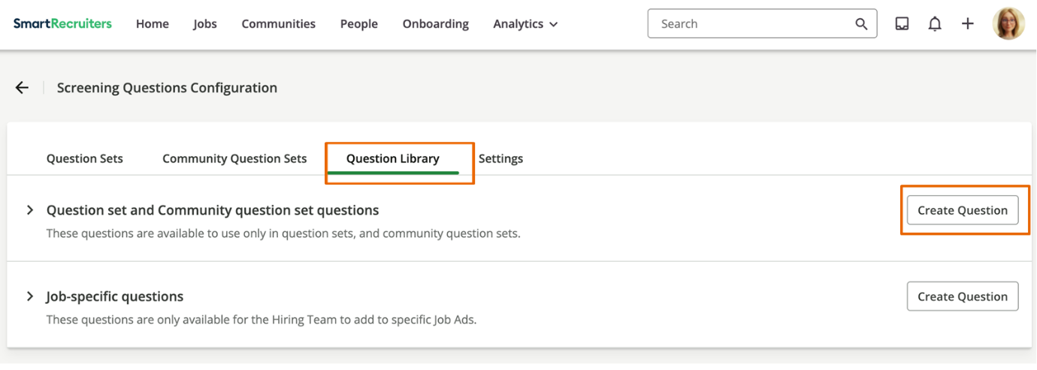
- Choose a question type.
It is possible to select free text to add information to the application form. The candidate will not be asked for a response. For example, a diversity statement may be added as a free text question before the diversity questions within a question set.
- Add a question title.
This will be the name of the question displayed in the library. Omitting a question title will revert to using the question as the title.
- Insert the question that is to be presented to candidates.
  - A maximum of 1440 characters may be used.
  - Basic markdown may be used:
    - Hyperlinks: [title](link)
    - Bold: **text**
    - Italic *text*
  - The following characters are forbidden:
    - <
    - >
    - ;
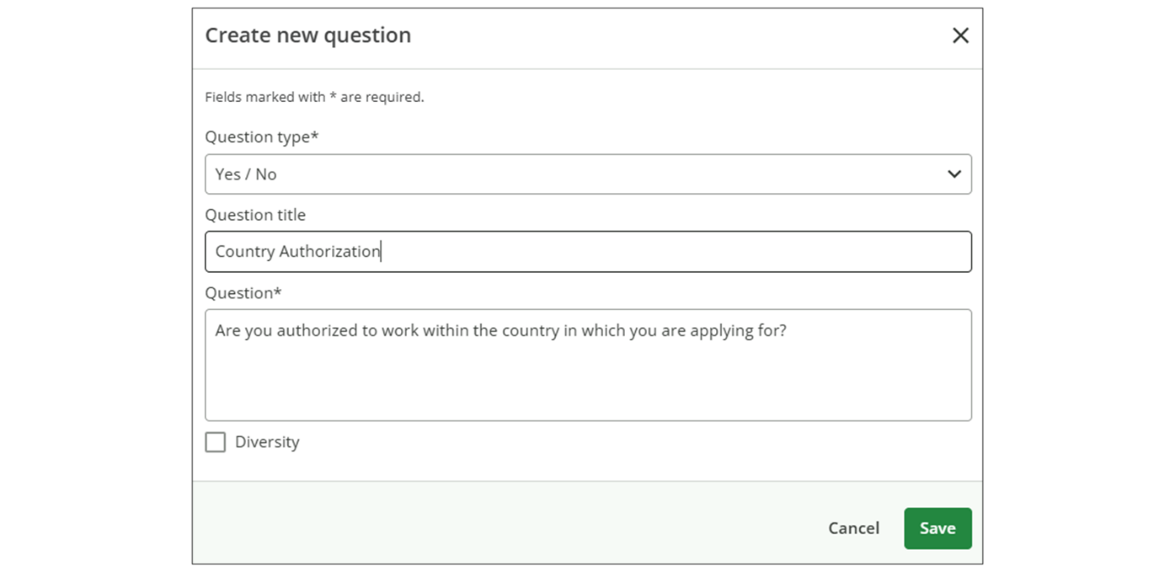
- If using this question in diversity reporting, enable the Diversity option. This controls who can view the data once provided by the candidate
- Select Save.
- Once the question is created, it will now become searchable in the Question Library. Search for your new question and add it to the question set.
- For custom questions, you can modify the Actions and Attributes of the question by selecting the Settings icon next to the question.
Actions will allow you to trigger an action based on the candidate’s response. For example, you can specify to Knock-out candidate if they answer with the undesired answer, or branch to another question if the candidate submits a specific answer. You may want to gather additional information about a candidate’s previous experience with the organization if they answer a question about whether they have worked for the organization before, such as their previous employee ID.
- Select Save.
Once a question set is activated, candidates will encounter it when applying for relevant jobs.
Watch the video below for more details about creating custom screening questions.
This video is for demonstration purposes. Any references made in this video to previous or later videos in this course (including titles, numbers, links, or sequence) may differ from the current course structure. Additionally, some functionalities shown may have evolved over time due to ongoing enhancements or business decisions.
Custom Question Sets
Custom question sets work and behave much like default question sets, except that their visibility in an application experience is determined by the org fields that they are assigned to.
Custom question sets will override default question sets when the org fields set matches a particular job.
Create a Custom Question Set
Steps
- Navigate to Settings.
- Select Screening Questions within the Configuration section.
- Select the Question Sets tab and select New set.
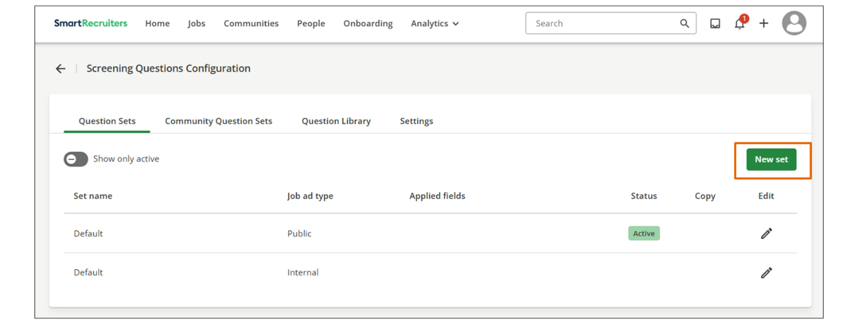
- Provide the following information to create the question set:
  - Name the question set.
  - Set whether it should be available to Public job ads or Internal job ads.
  - Define the org fields the Job should match to load this question set.
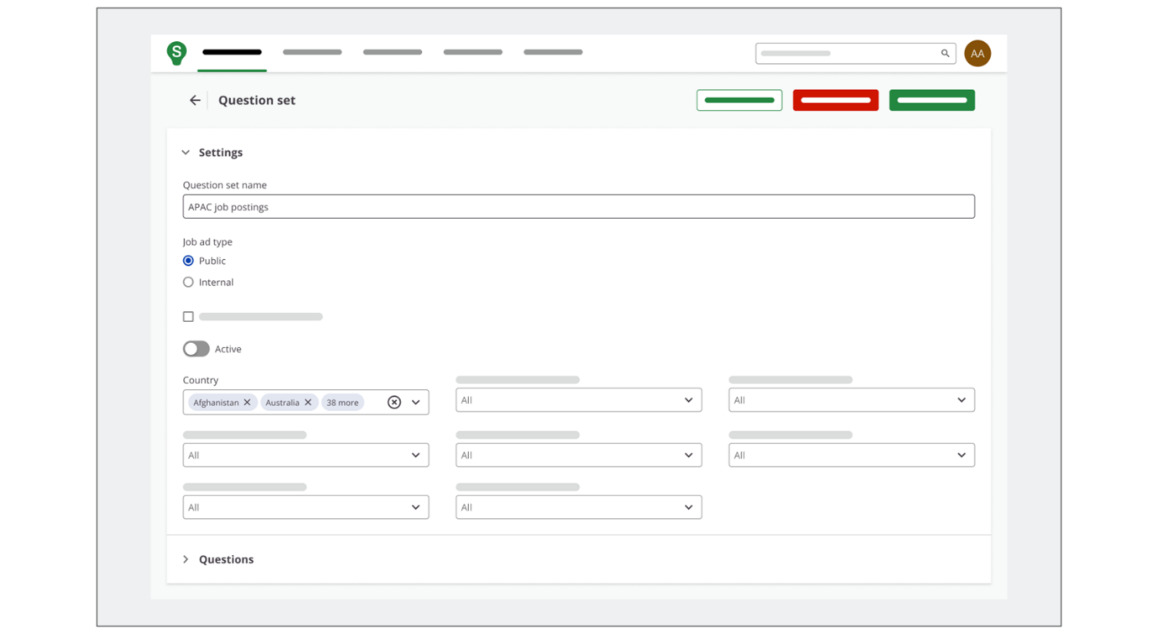
- Once you have completed these steps and added questions, you can toggle the question set to Active and save your new custom question set.
Limitations
  - A maximum of 100 questions is allowed per question set.
  - The maximum number of question sets is 500 per type of job (internal and external).
This means 500 Public question sets and 500 Private question sets.
Summary
- Custom screening questions allow administrators to create targeted inquiries tailored to specific roles or departments. These questions capture essential information about candidates, ensuring they possess the necessary skills, knowledge, or experience.
- Administrators create custom screening questions within SmartRecruiters by navigating to the Screening Questions settings.
- Manage custom questions by modifying actions and attributes, such as knock-out options based on candidate responses.
Creating Job-Specific Screening Questions
Objective
After completing this lesson, you will be able to configure job-specific screening questions in SmartRecruiters.
Job-Specific Screening Questions Overview
The primary use of job-specific screening questions is to provide a pre-interview screening filter for recruiters, moving beyond a simple keyword match on a resume. These questions are specifically configured to assess minimum qualifications for a specific job.
Within SmartRecruiters, you can create a customizable library of job-specific screening questions for a hiring team to use in addition to the application screening questions for their job. This feature enables recruiters to efficiently select relevant questions tailored to specific roles, streamlining the screening process and enabling more precise candidate evaluation.
Difference Between Application and Job-Specific Screening Questions
Application and Job-Specific Screening Questions Comparison
 | Application Screening Questions | Job-Specific Screening Questions
Description | These questions are global.  They are part of a Question Set configured in the system's settings and therefore apply to all job applications where they appear in a question set configured with org fields that match the job. | These questions are unique and tailored to the specific skills, requirements, and logistics of an individual job opening. They are added to the default questions for a particular requisition.  This allows the system to be configured to add screening questions to all jobs of a particular type (e.g., department) and enable a recruiter to add additional questions to an individual job where necessary.
Who will see these questions? | These questions will be applied to every job posting unless overridden. | These questions are added to one job posting (or a group of similar postings) at a time by a Hiring Team member.
Purpose | To collect mandatory, generic, and compliance-related information that is essential for any hire at the organization, regardless of the role. | To quickly and automatically filter candidates based on must-have qualifications that are unique to the role. This saves the recruiter time by preventing the review of unqualified applications.
Examples | - Are you legally authorized to work in [Country Name]?  - Will you now or in the future require sponsorship for employment visa status? (The answer to this is often a Knockout Question if the company doesn't sponsor visas)  - Questions related to EEO/Diversity data (e.g., gender, ethnicity).  - How did you hear about this job? (Used for recruitment source tracking).  - Customization: They are configured once at the organizational level and rarely change. | - For a Software Engineer: "Do you have 3+ years of professional experience using Python?  - For a Truck Driver: Do you possess a valid Commercial Driver's License (CDL)? (This is often a Knockout Question).  - For a Sales Executive: Are you willing to travel up to 50% of the time?  - For a Night Shift Manager: Are you available to work mandatory shifts between 10 PM and 6 AM?  - Customization: Highly customized by the recruiter or hiring manager for each job. They are often the Knockout Questions that determine whether a candidate is immediately disqualified or advanced in the hiring pipeline.
Key Feature Highlights
- The Job-specific Question Library, where administrators can create, delete, and modify job-specific screening questions.
- The Job-specific Screening Questions section in the Create/Edit Job Ad views, making screening questions accessible during job creation or editing.
- Job-specific Screening Questions Configuration enables hiring team members to select or remove relevant questions from the Job-specific Question Library, tailoring each job ad to include precise and effective screening questions for targeted candidate evaluation.
Enable Job-Specific Screening Questions
Follow the steps below to enable job-specific screening questions:
Steps
- Navigate to Settings.
- In the Configuration section, select Screening Questions.
- In the Settings tab, toggle Job-specific Screening Questions on.
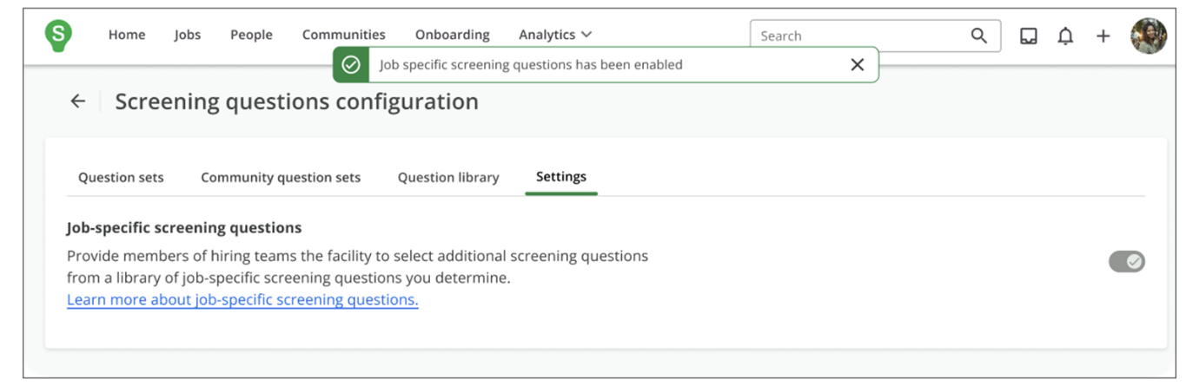
- Click Confirm to enable job-specific screening questions.
Create Job-Specific Screening Questions Library
After enabling the Job-Specific Screening Questions feature, a library of job-specific screening questions must be created. This library will allow the hiring team to select appropriate questions for a job ad.
Steps
- Navigate to Settings.
- In the Configuration section, select Screening Questions.
- In the Question Library tab, in the Job-Specific Screening Questions, select Create Question.
- Choose a question type.
- Add a question title.
This will be the name of the question displayed in the library. Omitting a question title will revert to using the question as the title.
- Insert the question that is to be presented to candidates.
  - A maximum of 1440 characters may be used.
  - Basic markdown may be used:
    - Hyperlinks: [title](link)
    - Bold: **text**
    - Italic *text*
  - The following characters are forbidden:
    - <
    - >
    - ;
- Select Save.
Grant Recruiters Access to Add Job-Specific Screening Questions
The ability to add screening questions to a job posting depends on a combination of system roles, access groups, and hiring team roles. To ensure recruiters have the necessary permissions, you may need to adjust their role settings within the Hiring Team and update their system access.
Steps
- Navigate to Settings.
- In the Permissions section, select Hiring Team Roles.
- In the Job Ad Tab row, select the pencil icon.
- In the Recruiter column, in the dropdown list, select Write.
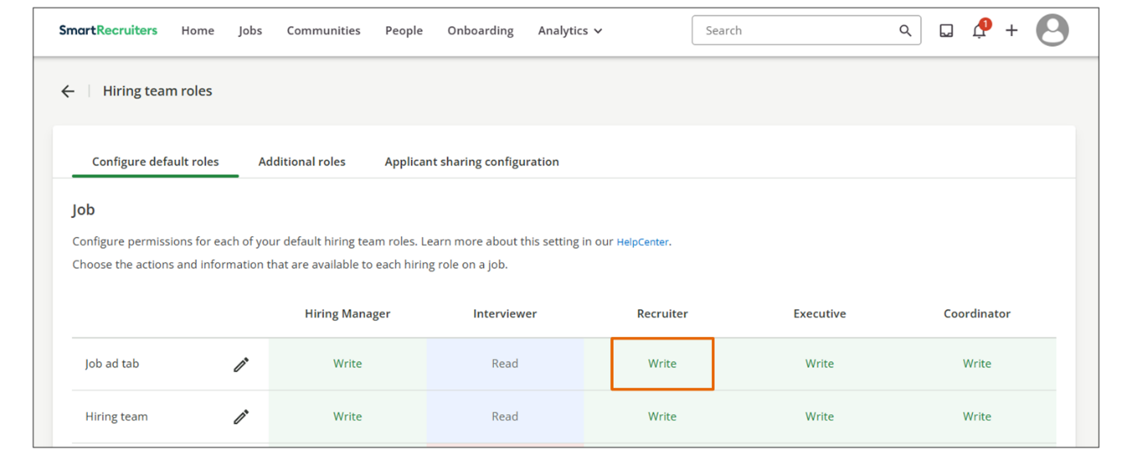
Result
This will allow any Recruiter added as a Hiring Team member of a job to add job-specific screening questions to the job.
Select Job-Specific Screening Questions in a Job
Follow the steps below to select job-specific screening questions:
Steps
- In the Jobs tab, click the job you want to select screening questions for.
- In the Job Ad tab, click Screening Questions.
- Click Job-specific Questions.
- Use the Question Library search bar to find the questions you want to include.
- Select the desired questions you wish to include, and these will be added to the job.
Note
You can add up to 50 job-specific screening questions per job ad for both internal and public publications.
Hint
Best Practice - Recruiters should carefully consider how many job-specific screening questions to add to a job. Large numbers of questions can reduce application ratings.
Summary
- Differentiate between application and job-specific screening questions to understand their unique purposes and applications.
- Enable Job-Specific Screening Questions in Settings to allow customization for specific job requirements.
- Create a library of job-specific screening questions to provide a resource for hiring teams.
- Grant recruiters access to add job-specific screening questions by adjusting hiring team role permissions.
- Select job-specific screening questions in a job ad to tailor the screening process for each role.
Creating Branching Application Screening Questions
Objective
After completing this lesson, you will be able to configure branching application screening questions in SmartRecruiters.
Branching Application Screening Questions
Branching questions in SmartRecruiters are a type of application screening question that enables the creation of dynamic, personalized, and efficient application forms.
​This functionality ensures that candidates are presented only with questions relevant to their specific circumstances or previous answers, minimizing application fatigue and maximizing the quality of the collected data.
Using branching questions, you can reveal additional questions based on the candidate’s answer to a preceding question. Branching logic works by setting up a conditional dependency between questions on the application form.
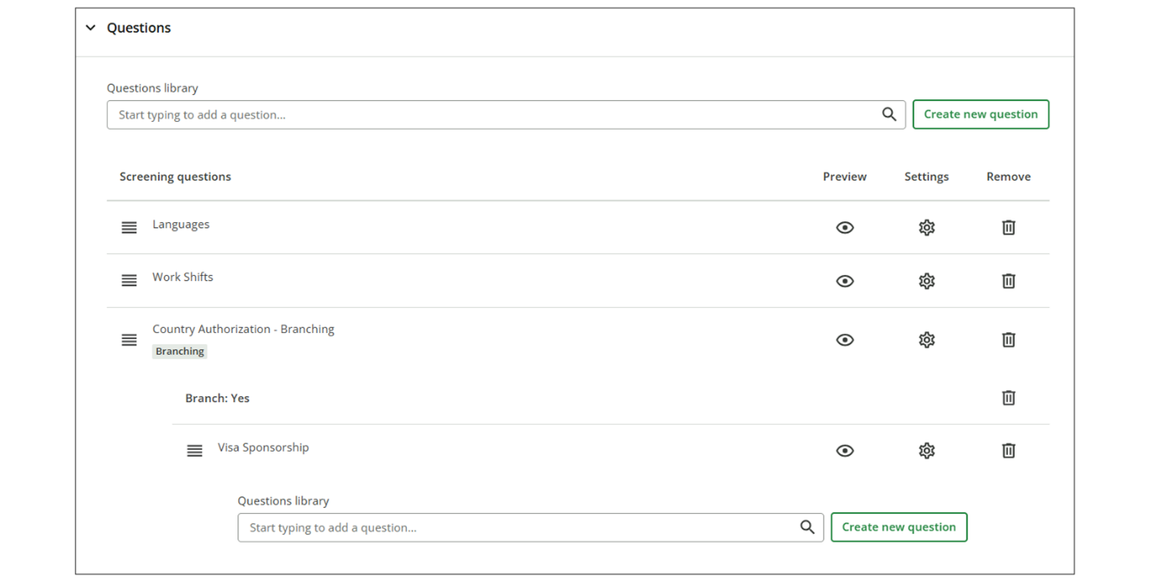
Example Scenario
If a candidate answers Yes to the work authorization question, a follow-up question asking for their visa type might be displayed. If they answer No, the application might skip the visa question entirely and instead present a final declaration.
Note
To use branching questions, the parent question, which triggers the branching question, must be created as a dropdown question type.
Create a Branching Question
Steps
- Navigate to Settings.
- Select Screening Questions within the Configuration section.
- Open a question set that you would like to create a branching question for by selecting the pencil icon.
- Expand the Questions section.
- Select the Setting icon for the question that you would like to create a branching question for.
The original question must be configured as a dropdown question type to be able to create a branching question.
- Within the Actions tab, find the answer to the question that should trigger the branching question.
  - Use the Action dropdown menu of the answer and select Create Question Branch.
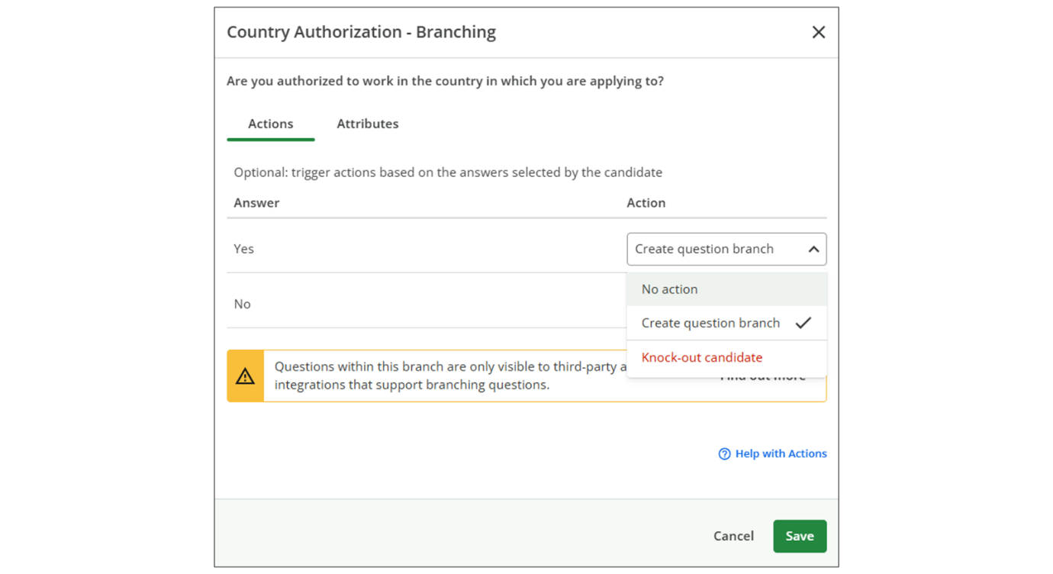
  - For each answer you wish to create a branch for, select Create question branch from the Action column.
- Select Save.
- Upon saving you will be presented with the ability to add the branching questions that should appear for each answer where Create question branch was selected.
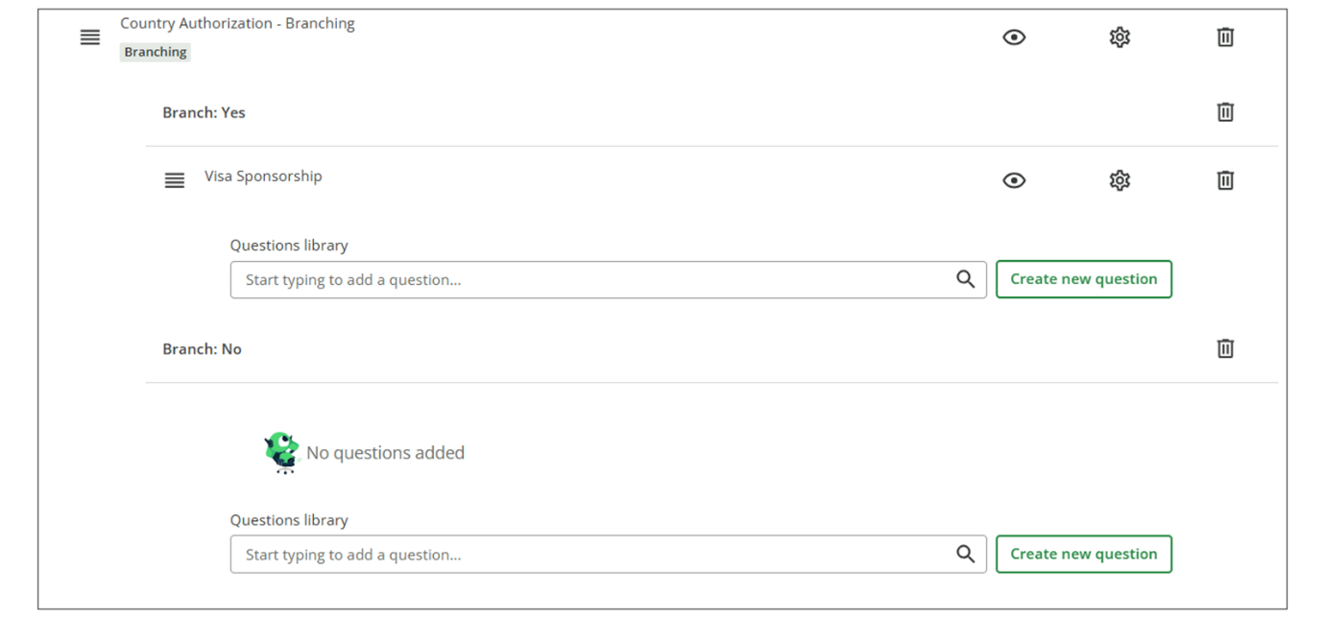
- Select Save.
Branching Questions Limitations
Branching questions have the following limitations:
- Branching questions should be set to 1 level.
- The branching question type must be a dropdown single select to ensure that the candidate’s response will match one of the branch options.
Questions from the Question Library can only be used once across a question set, including questions inside a branch. Therefore, you might need to configure multiple. For example, Extra information - education and Extra information - work experience as branching questions.
Summary
- Branching questions in SmartRecruiters create dynamic, personalized, and efficient application forms.
- Branching questions reveal additional questions based on a candidate's answer to a preceding question.
- The parent question (which triggers the branching question) must be created as a dropdown question type.
- Branching questions should be set to 1 level.
- The branching question type must be a dropdown single select.
Creating Rejection Screening Questions
Objective
After completing this lesson, you will be able to configure knockout rejection questions and the rejection process.
Knock-out Rejection Questions
Knock-out questions automatically disqualify candidates who provide an undesirable answer. For example, if a candidate answers no to the question "Do you want to work in an office location?", he can be automatically removed from the application process.
You can configure any question that is already added to a Screening Question set to be a knock-out question. Any yes/no or dropdown screening question, except diversity questions, can be configured as knock-out questions. SmartRecruiters will automatically reject candidates who choose answers marked as knock-out when completing their applications.
The configuration applies on a set-by-set basis, rather than the question itself so that each question can be:
- a knock-out question with a specific configuration in one set
- a knock-out question with another configuration in another set
- a normal question in another set
You can also configure which users can see the question, allowing you to restrict access to sensitive information.
Hint
It is considered best practice to carefully consider legal/compliance/candidate experience implications when configuring knock-out questions.
Note
Remember that another option is for the recruiter to filter by screening question answers and bulk process rejection.
Create a Knock-out Rejection Question
To configure a knock-out question:
- Navigate to Settings.
- Select Screening Questions in the Configuration section.
- On the Question sets tab, select theEdit icon to edit an existing set.
- On the Create or Edit set page, select the Settings icon for the question you would like to configure. (Add a new question if necessary.)
- In the Actions tab, select each answer you want to trigger a knock-out and choose Knock-out candidate. At least one answer must remain unchecked. 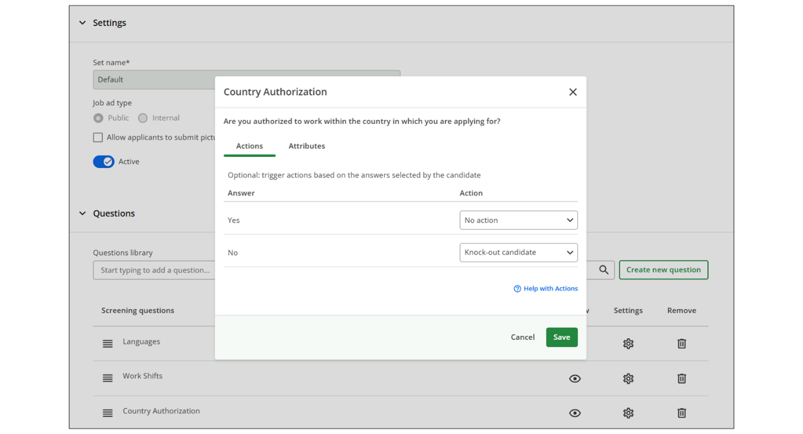
- Select Done to finish.
Rejections for Knock-out Questions
When using knock-out questions, it's essential to consider a rejection process to inform the candidate that their application will not be proceeding, as well as logging a rejection reason for reporting purposes. This involves selecting a rejection reason and optionally sending a rejection email to the candidate.
Hint
It is best practice to configure a rejection email so that candidates are kept fully informed. Include a valid reason that they are not being considered.
For each screening question set with at least one knock-out question, you will have the opportunity to configure:
- A rejection reason that SmartRecruiters should assign to a candidate's application when they answer a screening question incorrectly.
- A rejection email that SmartRecruiters should automatically send to the candidate after rejecting them for answering incorrectly.
The Reason for rejection is required. SmartRecruiters will default to the Did not meet screening requirements reason, but you can choose a different one from your list of standard reasons (as well as custom reasons, if any are configured).
The rejection email is optional. Should you choose to send one, you can use any Rejection email template (or write a new one) and set up a Delayed Rejection.
Rejection email delay options are:
- 1 hour after the candidate submits application (default)
- 2 days after
- 5 days after
Rejections set up for specific candidates, when you configure a Delayed Rejection for a knock-out question, SmartRecruiters will mark the candidate as rejected immediately but will delay updates to the Applicant Tracking Portal and will delay sending the rejection email to the candidate until the delay period elapses. This ensures the candidate experience is consistent.
Watch the video below for more details on rejections for knock-out questions.
This video is for demonstration purposes. Any references made in this video to previous or later videos in this course (including titles, numbers, links, or sequence) may differ from the current course structure. Additionally, some functionalities shown may have evolved over time due to ongoing enhancements or business decisions.
Summary
- Define knock-out questions and how they automatically disqualify candidates based on undesirable answers.
- Configure questions within a Screening Question set to act as knock-out questions, excluding diversity questions.
- Apply knock-out configurations on a set-by-set basis, allowing flexibility in how questions function across different sets.
- Set up a rejection process for knock-out questions, including selecting a mandatory rejection reason and an optional rejection email with delay options.
Hi, in this video, we will
review how to configure rejections for knockout
screening questions and how to determine whether
or not a candidate was knocked- out and rejected from one of your
knock-out screening questions. In our last video, we reviewed
creating question sets, so we'll continue on using the same question
set that we previously used. We'll want to make sure that
we give this set a title. Now that we've configured
our question set to apply to these departments and we're
happy with our questions, we want to make sure that if
we are leveraging a knock-out screening question that
we configure a rejection. What this means is that once a
candidate answers the knock-out screening question incorrectly, they will be
removed from your hiring process and you have the option to send a
rejection email to that candidate and of course select the disposition for
the rejection. There is a list of dispositions that you can select
from. So for this example, we'll go ahead and say that this candidate did
not meet the screener requirements. If you want to send a rejection
email, you can do so, or you can toggle this off if you don't,
which will close the setting. You can come in here and you
can select any of the templates that you've created in your
other settings, or you can create a custom template right
here within the setting itself. Please note that if you do
create a custom template, it will not appear on your
email template settings, but it will only be leveraged
on this question set. For this example, we'll go ahead and
use one of the default templates. As you can see, the fields were
filled out and if a candidate is rejected, they will be met
with this template itself. You can also select whether or not you want to send a delayed rejection, meaning that if the candidate
is knocked out, you can have the rejection email be sent out one hour
later, a couple of days, or even five days later. Once you're
happy with your selections, you can go ahead and save and make
this question set active. Now that this question set is activated,
candidates will be met with the screening question set you've
configured when applying to your job. From a candidate's perspective,
when they apply to your job, they will be met with the new question
set that you created. As you can recall, we had configured the do you
want to work in an office location and made it so that if the
candidate answered no, they will be knocked out of your question set.
For the example of this video, we're going to go ahead and force a
knock-out through this candidate application. The candidate application
I submitted was named Jim Smith. When you access the Jobs people list,
you will see Jim's application at the top of the list and notice that
he has been rejected with a knock-out screening question, rejection
reason pending. If I open up Jim's application, you will also notice on
the right-hand side of the screen the rejection reason that we selected
when configuring the question set. It does match, so we can see that
Jim did not meet the screening requirements based on the knockout
question that I configured. You can also review the question
sets under the More option, Screening, and then see the actual
question itself that Jim answered. Everything lines up here, so
I know that Jim is knocked out due to the incorrect answer
of the screening question. Thank you.

Viewing Screening Questions in the Application
Objective
After completing this lesson, you will be able to manage the visibility of screening questions and candidate responses.
Screening Questions in the Job
Understanding how candidates are screened is crucial for ensuring a fair and effective hiring process. The screening questions in the Job Ad tab provide a user-friendly way for non-administrators to preview the questions candidates will be asked, as well as the actions and attributes configured for each job ad.
This transparency helps ensure that everyone involved in the hiring process understands the criteria used to evaluate candidates.
This is especially important for recruiters collaborating on roles to know what information can be used to filter candidates.
Preview Screening Questions Configuration for a Job Ad
Steps
- Navigate to the Jobs tab.
- Open a job for which you want to preview the screening question configuration.
- Select the Job Ad tab.
- Select the Screening questions link located in each Job Ad.
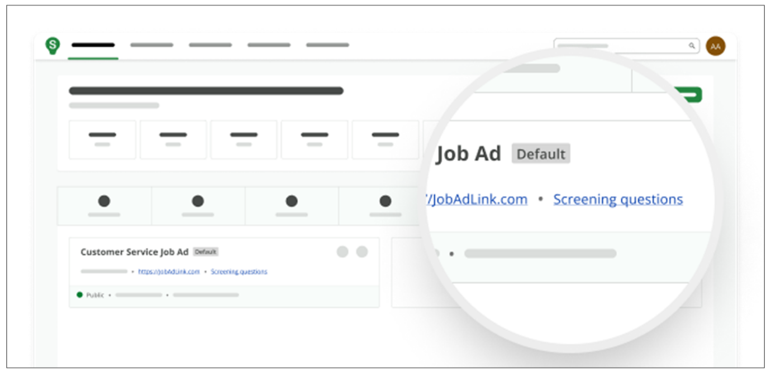
Alternatively, you can select an available Job Ad, then select Screening questions on the Job Ad details.
- The public screening questions configuration will be shown by default when available.
  - When screening questions are configured, Public and Internal screening questions will be presented across two tabs.
  - Select an available tab to see the screening questions' configuration.
Screening Question Responses
By default, a candidate’s answers to any application screening questions are visible on their profile to anyone with access to the candidate.
- Administrators can choose to restrict the visibility of individual screening questions (and their answers) to only users with full access to the candidate.
- Answers to application questions are displayed in a candidate’s profile and in the candidate’s portal.
- Candidate answers to application questions do not show up in the Applicant Flow report.
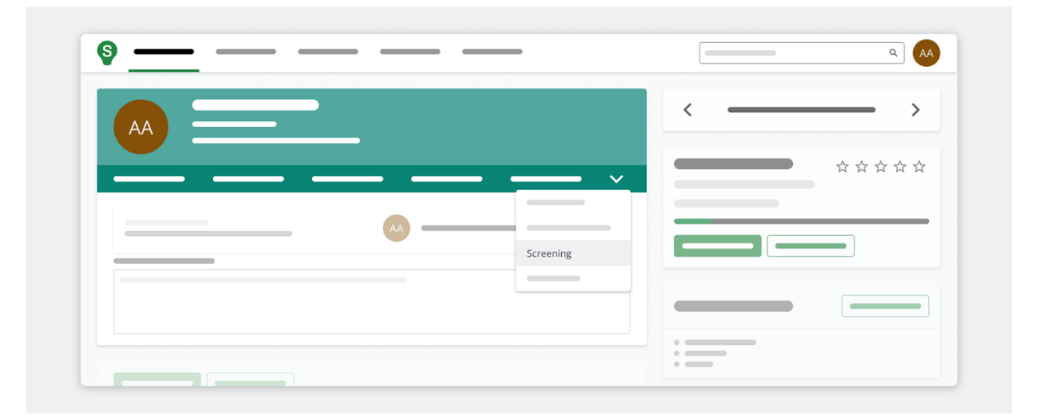
The following screening question visibility options are available:
- Visible to all users: anyone with access to the candidate's profile can see the question and answer.
- Only users with full access: users with full access include Executives, Recruiters, and Hiring managers.
- Hidden to all users: applies to diversity questions only.
If a candidate has made alterations to their screening questions, you can observe the different submissions using the See Versions dropdown menu button located top right of the screening page.
In general, questions marked as Diversity (and candidate answers) are omitted from the candidate's profile. Only administrators can see the answers in the Applicant Flow (EEO only) and Diversity reports, obtainable from the Templates dropdown within the Report Builder.
Note
There is one exception for EEO questions, which are partially visible to users who have access to the candidate.
Configure Screening Question Visibility to Users
Steps
- Navigate to Settings.
- Select Screening Questions within the Configuration section.
- Select the Question Set tab.
- Select the pencil icon for a question set you wish to modify.
- Expand the Questions section.
- Find the question you wish to modify the visibility settings for.
  - Select the Settings icon.
- Select the desired Answer visibility setting.
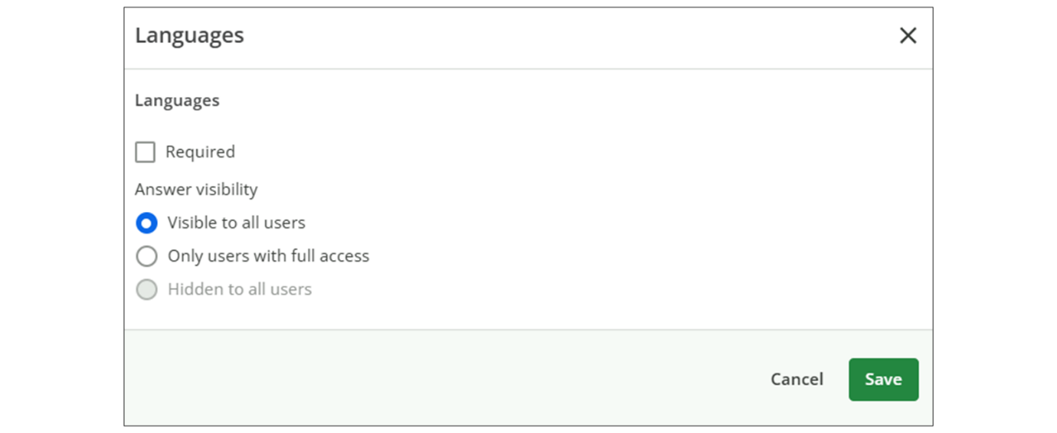
- Select Save.
Summary
- Previewing screening questions in the Job Ad tab provides transparency in the hiring process, ensuring all stakeholders understand candidate evaluation criteria.
- Candidate responses are visible by default but can be restricted to specific user roles for data privacy and compliance.
- Administrators configure visibility settings through the Screening Questions configuration, ensuring appropriate access control and adherence to regulations.
Creating Custom Forms
Objective
After completing this lesson, you will be able to create custom forms in SmartRecruiters to collect additional candidate information.
Custom Forms to Collect Additional Candidate Information
SmartRecruiters allows you to create custom forms to gather specific details, such as references or additional qualifications from candidates, streamlining the hiring process and ensuring you have all the necessary information to make informed decisions.
Custom forms in SmartRecruiters are a powerful tool for gathering additional information from candidates who have already applied. These forms allow you to capture specific details beyond the standard application process, ensuring you have a comprehensive view of each candidate. Forms can be sent ad hoc or associated with email templates and even sent through bulk or automated distribution using hiring process workflows.
This approach can be used in situations where additional information is required but a screening question would be inappropriate due to the early stage a screening question is asked. For example, you may want to gather references towards the end of a hiring process rather than at the beginning so the form could be attached to an email template that is automatically sent to the candidate when they reach the final interview step of the hiring process.
Hint
Best practice - It is important to train the recruitment team to only move candidates forward in the process once all mandatory information is provided by the candidate.
Under Settings, there is a page called Forms which allows administrators to see basic information such as:
- a list of all forms
- which email templates a form has been added to (click on the number of templates to see a complete list)
- when the form was last modified (and by whom)
- whether the form is active or not (more details in the Sending custom forms section)
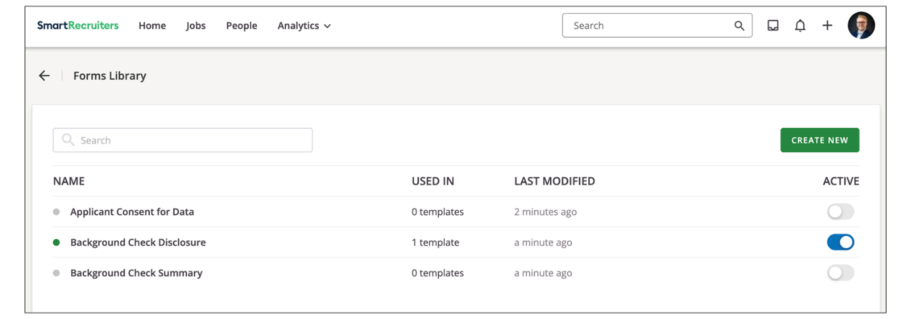
All edits will only apply to forms that are sent on a going forward basis. All forms that have been sent to candidates regardless of whether they have returned the form will not be updated. Recruiters will need to be notified of the change and determine whether the updated version of the form needs to be sent to the candidate.
While there is no limit to the number of forms that one account can set up, each form can only include a maximum of 100 application fields.
Hint
For optimal candidate experience, it is recommended that each form stays well below this maximum count. Application fields can be split into different forms if needed so that candidates are not overwhelmed by the number of questions.
Sending Custom Forms to Candidates
Custom forms can be shared with candidates in three ways:
- Sending Forms Ad Hoc: You can send forms individually to candidates by composing a message and attaching the desired form. This is useful for targeted information gathering based on individual candidate profiles.
- Associating Forms with Email Templates: Forms can be integrated into email templates, allowing you to automatically send them to candidates at specific stages of the hiring process using workflows. This ensures consistent data collection and saves time.
- Creating Custom Forms: To create forms, navigate to Settings and under Configuration, select Forms. This section displays a list of existing forms, their status (active or inactive), associated email templates, and modification history.
Tracking Candidate Submissions
Once a form is sent to a candidate, the form name, status and last updated date will be available in the candidate’s profile in a new tab called Forms. With three different status available:
- Scheduled: to be sent (if the form is attached to a Send Message notification through Workflows Automation)
- Sent: pending candidate to complete the form
- Completed: by the candidate
All behaviors of an application field will stay the same (for example, public API integrations and Report Builder functions using application fields will continue to work as-is).
When a recruiter clicks on a form, they will be able to see the list of fields that were sent to the candidate underneath the summary to make it easier to review candidate submissions. This list will be limited to what has been configured in Application Management, if this is selected to appear on the Candidate Profile and if the user needs full access to see it.
Edits to candidates fields can now be completed through the Application fields widget as well as on the Forms tab. Users will just need to select the form they would like to make edits to or select View all fields to see all application fields, and click on the Edit button on the top right corner in the summary box to make changes. A Save and Cancel button will appear at the bottom once the user is in Edit mode to save all edits.
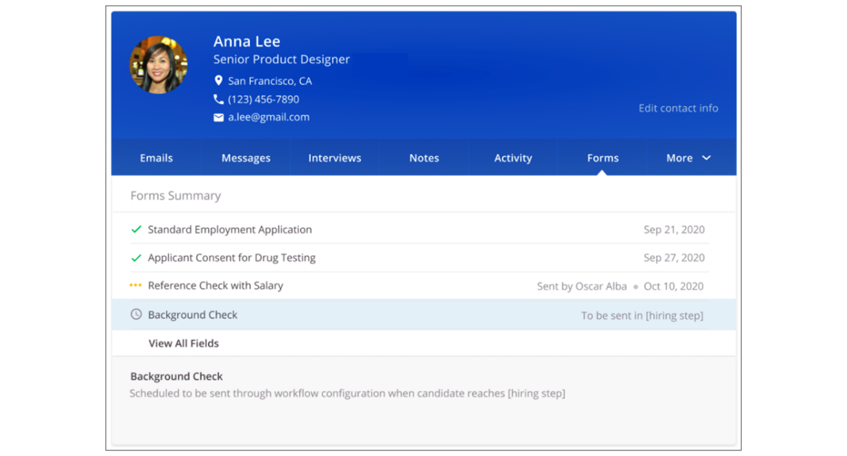
What each user sees in this tab is controlled by the permissions set in Application Management and Settings→ Hiring team roles under Application Fields and Restricted Application Fields.
Form submissions are tied to a candidate's application and will not be transferred if they are moved to another job. Recruiters will need to send the form based on that application to ensure the data is up-to-date and relevant to the new job they are added to.
Build a Custom Form
Steps
- Navigate to Settings.
- Select Forms within the Configuration section.
- Select Create New.
- Enter a name for your form (for example Referee Information).
- Use the available candidate fields on the left-hand side and drag and drop them onto the form.
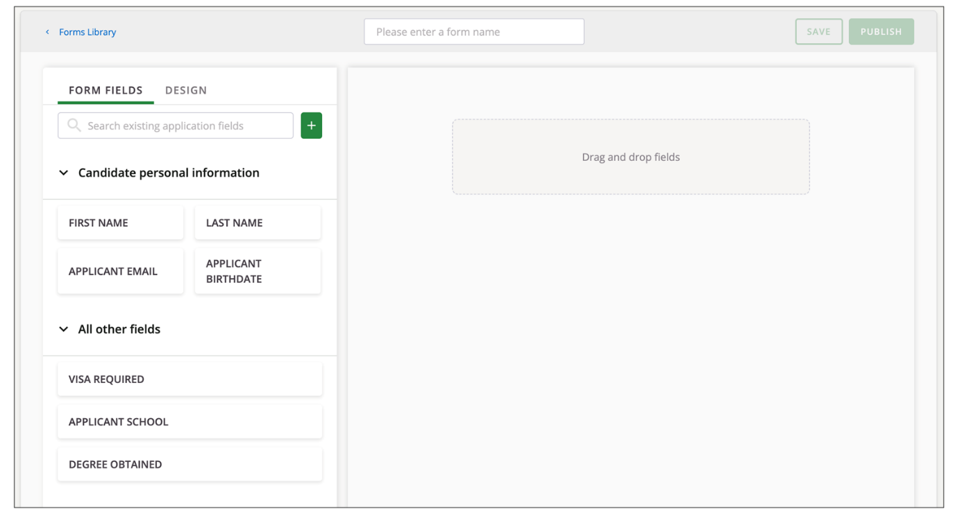
- Customize your fields using the following options:
  - Field Title: Change the presentation of the field to the candidate. This is useful if the internal field name is not easily understood by candidates.
  - Hint Text: Provide tips or instructions to guide candidates on completing the field.
  - Required: Specify whether the field is mandatory.
- Create new fields, if necessary, directly within the form builder.
  - Select Add and enter a name for the new field (e.g., House Name/Number).
  - Configure the field type (for example, free text, hint text, and whether it's required).
  - Specify where the field should appear within the system (for example, candidate profile, new hire form).
- Organize your form by using the drag and drop functionality to arrange fields in a logical order. Use divider lines to visually separate sections of the form.
- Select the Design tab to include instructions and dividers in your form.
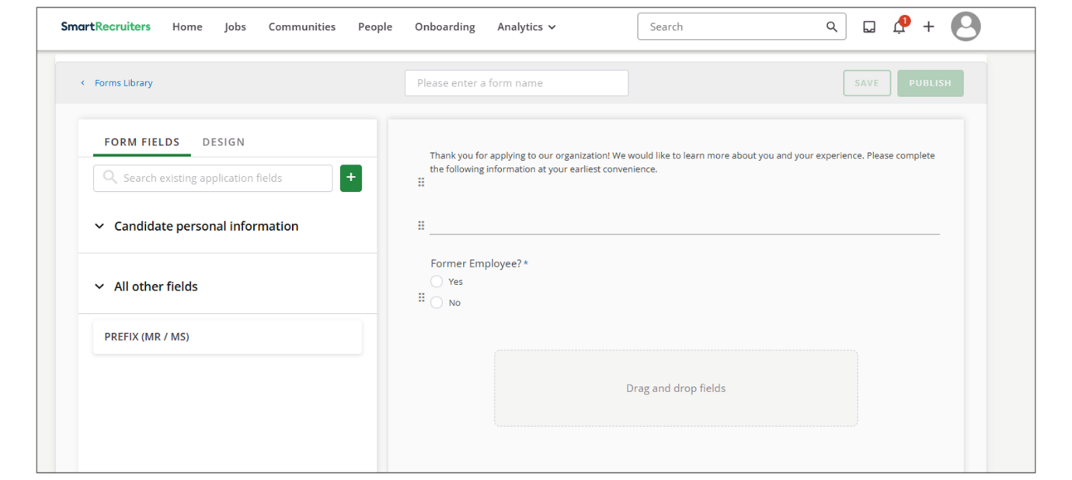
- Select Save.
  - The form is not yet available for use.
- Publish the form to enable the form for use.
  - You will be prompted to return to the library or go to templates to add it to an email template.
  - Once published, the form is available in the Add Form list when composing messages to candidates.
Watch the video below for more information on this topic!
This video is for demonstration purposes. Any references made in this video to previous or later videos in this course (including titles, numbers, links, or sequence) may differ from the current course structure. Additionally, some functionalities shown may have evolved over time due to ongoing enhancements or business decisions.
Summary
- Custom forms in SmartRecruiters allow you to collect specific information from candidates beyond their initial application.
- Forms can be sent ad hoc or associated with email templates for automated distribution.
- You can create and customize forms by dragging and dropping existing candidate fields or creating new ones.
Hi, in this video, we're going
to take a look at custom forms in SmartRecruiters. So, if we've got
a candidate who has already applied, so they've been through the
application process, they've answered our screening questions, but
we want to capture additional information from them, we can use
forms and we can send those out to the candidates to complete and then have
that information come back into those fields in the system. Forms
can be sent ad hoc, so I can just come in, I can type my message
to the candidate and I can then add a form from anything that we
already have created. And that will add in a link to the form that
the candidate can then complete. Forms can also be associated with
email templates. So if I select this additional information
template here, then you'll see that I've got a link already to
one of the forms I've created. So to create the forms
themselves, we do that in Settings and Admin, underneath
Configuration and select Forms. Here I'll have a list of any
forms that already exist, whether they're currently active or
not, whether they're currently associated with any of our email
templates and when they were last modified and by whom. I can go
ahead and create a new template. And the first thing I'll need
to do here is enter a name for my form. So I'm going to just
call this Referee Information. And then I basically come and build
my form. So I can use my fields available here on the left hand
side. So these are candidate fields that have been previously
created. And if I want them in my form, I can simply pick them up
and drag and drop them over here. So I'm going to ask them for
their first name, last name. Maybe I want them to
confirm their address. And then I'd also like them
to provide me with their referee name and email
and referee phone number. drag and drop that. With each field
you have the ability to edit a couple of options on them so you can
see that when I dragged over first name it actually changed it to
legal first name and that's because I've previously retitled it on
another form so I can come in and have the presentation to the candidate
appear slightly different to how we've named the field in the system
so that can be useful you know if maybe in the system you've created
something that maybe wouldn't necessarily make sense to the
candidate, you can retitle it for the purpose here, as long as, of course,
you will understand what it is when it comes back into the system.
You can also add hint text if you need to give the candidate any tips
on what information to complete in this field, and you can choose
whether or not it should be required. The field internal name and the
field type are not something I can edit because this field already
exists. It's going to keep those properties. So I'm going to go
ahead and save that. Maybe I want to update last name so it reflects
the legal bit as well. So clicking on the field itself in this field
title box here, I'm just going to rename that to legal last name
and save and you'll see that's now updated on my form. If I've got here
and I think actually I really need a field for house name or number,
rather than having to go back to the candidate field section, you
can create an additional field here. So I'm going to select add. I'm
going to call it house name number and I'm going to have it called
exactly the same on the form itself. I'm not going to add
any hint text in here. I'm going to leave it as a free
text field but the options available to you here are exactly the same
as they are on the Candidate Field Creator page. I'm going to make this
required and then again I've got those exact same options as I have when
I create a candidate field in that Candidate Field section. So do I
want only users with full access to see the data or all users and where
in the system does this field appear? If I only need it to appear in the
form here I don't need to check any of the boxes but if I do want
this information to be presented on the Forms tab for the candidate I do
need to select candidate profile and perhaps I actually want this
information to appear on the new hire form so we can confirm their address
at that stage I can check the box here too. I'm going to go ahead and
save that and it will automatically drop it to the bottom of my form so
I'm actually going to drag and drop that up to the top here so that it's
in a logical order and I can see I've now got all the fields that I
want for this particular form. What I might want to do is just add in
the divider line here to separate out those kind of contact details
from the referee details underneath. So I've got all the information that
I want the candidate to complete now and I'm going to go ahead and
save it or publish it. So if I save it it means I can come back and edit
it later on. Of course we can edit them at any point but it means it's
not actually ready for use yet. So if I'm kind of halfway through
and I want to come back to it later just save it. But if I'm ready for
it to be used I can go ahead and publish it and you'll then be prompted
with this screen to take you back to the library or go to templates
if you actually want to go ahead and add it to one of your email
templates but we'll take a look at how we do that in our email template
video later on. If I go back to the library I'll then see that my form is
this one here created a few seconds ago. It's active and I can see the
details here for any point I want to come back in and edit it I can
select the form itself and I can come through and make my edits and of
course if I go back to my candidate now if I do want to send this out,
that form will be available because I've published it and if I take a
look in my ad form list here I can see my referee information form
is available. So that's how we can create our forms within SmartRecruiters and we'll take a look at how we associate them with email templates in a later video. Thank you.

Enabling Candidate Sources
Objective
After completing this lesson, you will be able to enable custom candidate sources in SmartRecruiters for source tracking purposes.
Candidate Sources Management
​​Understanding where your candidates originate is crucial for optimizing your recruitment strategies. SmartRecruiters allows you to track candidate sources, even those not directly integrated with the platform. This allows you to monitor the effectiveness of various recruitment channels beyond standard job boards.​ ​​
​​​For example, you may want to attract applications from a specific career fair and need to report ​on the volume​ and quality of these applications.
SmartRecruiters has a Source Library that consists of a three-level structure that groups different sources together.
Each source is organized first by type, then by sub-type, and finally source name.
- Types: Generically classify groups of sources by the way they add candidates to SmartRecruiters. For example, paid sources.
Note
All sources have a type.
- Sub-types: More specifically classify groups of source. For example, job board, when necessary.
Note
Not all types have sub-types.
- Source Names: Uniquely identify specific sources. For example, LinkedIn. This name is displayed on the candidate's application.
Note
All sources have a name.
For example, the full definition of the LinkedIn source, which is a job board that charges for each job posting, is:
- Type: Paid
- Sub-type: Job Board
- Item: LinkedIn
Note
LinkedIn has a number of sources to enable users to track the different ways in which a candidate may enter SmartRecruiters from LinkedIn. For example, LinkedIn Recruiter.​​​​
Use Cases for Custom Sources
- Niche Job Boards:: Track candidates coming from job boards not directly integrated with SmartRecruiters.
- Career Events: Monitor the effectiveness of career fairs and other recruiting events.
- Job Widgets: Allocate a specific source to your job widget to track candidates applying through that specific channel.
- Walk-ins: As in the example, track candidates who apply in person.
By setting up custom candidate sources, you gain valuable data on where your best candidates are coming from, allowing you to refine your recruitment strategies and allocate resources effectively.
Default Sources
The default library, which is available on all editions, includes the following standard sources:
Organic: Organic sources are unpaid job postings and include free job aggregators. Each job aggregator can be tracked as a separate source by name.
Career Page: If you have multiple career pages, they're identified by name, and you can track each as a separate source.
Social shares: Candidates from Facebook, LinkedIn, and Twitter. Each network share has a separate source name.
Internal: Candidates with an Internal sub-type applied via an Internal job ad, and have one of the following sources:
- Contract to Permanent
- Direct Link
- Employee Portal
- Intern to Permanent
- Internal Career Page
- Internal Transfer
Google Search: Candidates who found a job through Google Jobs Search will have a source of Google Search.
Manual upload: This source can be used to indicate that the candidate was manually added to the system, in cases where no other relevant source applies. Please note that it is not automatically set when adding the candidate, it must be chosen explicitly by the user.
Paid: Paid sources come in three sub-types. Each board is a separate source and can be identified by its name.
- Job Boards: Paid job boards, for example: LinkedIn.
- Pay per Performance boards: Job Boards that charge by the click, view, or other events, for example, Indeed.
- SmartJobs: Candidates generated through our internal candidate database.
Referrals: Referrals sources come from current employees and managers in SmartRecruiters.​ These sources can be especially useful if the organization has a referral bonus scheme in place.​
Agency: Agency sources include recruiters and other contracted sourcing agencies, particularly those whose services can be purchased through the Marketplace. Agencies can be tracked separately by name.
CRM: All CRM (candidate resource management) have one of the following sub-types: Sourcing Tools, Job Alert, Talent Pool.
Other: Other sources have the Other sub-type and a source name. The source name is configured when adding the Other source in the Source Library.
There are three default source sub-types:
- Event
- Campaign
- University
Add a Custom Source
To add a new custom source:
Steps
- Navigate to Settings.
- In the Configuration section, click Custom Candidate Sources.
- Click Create source.
- In the Source Name field, enter a name for the source. This name will be displayed on the candidate's application and in your Sourcing Analytics.
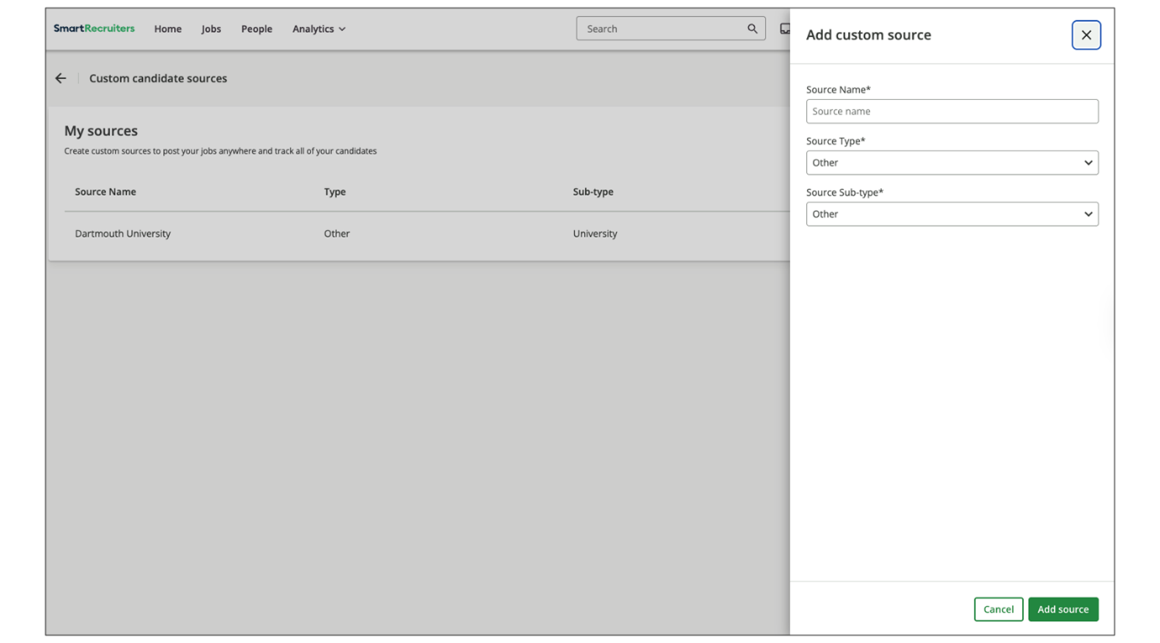
- Choose the Source Type.
  - Options include Organic, Paid Source, Agency, CRM or Other.
  - If the source doesn't fit the categories, select Other.
  - If you select Other as the source type, you can further specify the Source Sub-type, such as Event, Campaign or University or keep Other.
- Select Add source.
Watch the video below for more details about creating custom candidate sources.
This video is for demonstration purposes. Any references made in this video to previous or later videos in this course (including titles, numbers, links, or sequence) may differ from the current course structure. Additionally, some functionalities shown may have evolved over time due to ongoing enhancements or business decisions.
Summary
- Tracking candidate sources is crucial for optimizing recruitment strategies.
- SmartRecruiters Source Library is a three-level structure: Type, Sub-type, and Source Name.
- Custom sources can be created to track niche job boards, career events, job widgets, and walk-ins.
- The default library includes organic, career page, social shares, internal, Google Search, manual upload, paid, referrals, agency, and CRM sources.
- Custom sources can be added in Settings under Custom Candidate Sources.
Hi and welcome to this lesson
on Custom Candidate Sources in SmartRecruiters. So we saw in
one of our training sessions on job adverts that we're able to
come through and create a custom source URL if we want to be
able to track candidates from a source that is not directly posted
to from SmartRecruiters. So we can come here, select the plus
button, choose the source type and then we can come and select our
source to create that custom URL. So we also saw that when we
were configuring our job widget, we are also able to allocate a
specific source to that widget. So again, we can track where
our candidates are coming from. So when we do this, we
need to have those sources already set up. And in
Settings and Admin, underneath Configuration, we can do this
in Custom Candidate Sources. So here we'll see a list of any
sources that have been created. And again, we want to use these
for things that we can't post to directly through the system. so
niche job boards or perhaps for career events that we want to
track and again for things like the widgets that we want to be able
to track a specific source for. So if I want to come in and
create a source first thing I can do here is type in my source name.
I'm going to call this walk-ins and then I'm going to choose my
source type so in this case this is going to be other it's not really a
free source or a paid source agency or CRM and I'm going to leave
that set to other but if you are creating perhaps a source for a
specific job board, you can come through and choose the paid option here and
then for your source subtype, that will give you the options available
to you. As I said, we're going to select other here so that will
automatically default to other but I can choose if this is an event,
a campaign or university. Once I save this, that custom source will
be added to my list for me and it's now available for me to use in my
custom source URLs or also if this were for a widget, I'd be able to
add this as the source on my job widget. That ends this lesson on
custom candidate sources. Thank you.

